**Abstract**

A large amount of data which has been handled over a sector in note to that the data which has been collected from the source will be stored in a database. The admin has the authority of approving the manager so that after the approval of admin the manager can access the application. Once the manager gets declined by the admin they can't able to login in that process which the manager won’t be able to access the application. The details which have been stored can be retrieved later, in case of using those details or viewing those information. The admin and the manager is one who can able to view the actions performed by the employees, by handling these data by the admin. The admin can view the data. In case of loss of data or theft of data in a form of attack the manager and the admin can view the details of the employee who has been attacked in the form of tables. The action can be performed here. The details can be attacked by four methods such as a data linkage attack, attribute attack, table linkage attack and probabilistic attack. By these attacks, we can attack the details of an individual by getting their id which has been published. By this action the manager and the admin can view the details of the employee who has been attacked

**LIST OF FIGURES**

**Fig.No Figure Name Page No**

**LIST OF ABBREVIATIONS**

**S.NO WORD ABBREVIATION**

**CHAPTER-1**

**INTRODUCTION**

* 1. **INTRODUCTION TO PROJECT**

A security system identifies and mitigates the system vulnerabilities, by eitherremoving them, or restricting access to them, to a very small group. The competition betweeninventing new security measures to protect data and inventing hacking techniques inconjunction with discovering and leveraging pre existing vulnerabilities is infinite. Therefore,securing data and resources is becoming more and more challenging day by day.Nevertheless, there exist several different techniques to secure the data being transferred overa network and also that on a user machine. Specializes in securing data in motion through theuse of the patented REL-ID based mutual authentication scheme.It can be used to ensure that the end user is secured as well as the tunnel. It also uses techniques of authentication to assure to each end user that it is communicating with an authorized user and not a fake one. Such security measures are used to secure data in motion, meaning data that has been shared between computers.

* 1. **PURPOSE OF THE PROJECT**

This application is based on a company that holds complete information about the employee and the manager which has been managed by an admin in a company the need for this application is to enhance the details of the employee whether it is a secured data. Sincea large amount of data has been handled over a sector in a note that the data which has been collected from the source will be stored in a database. The admin has the authority of approving the manager so that after the approval of admin the manager can access the application. Once the manager gets declined by the admin the can't able to login into that process the manager won’t be able to access the application. The details which have been stored can be retrieved later in case of using those details or viewing those information. The admin and the manager is one who can able to view the actions performed by the employees. By handling these data by the admin. The admin can view the data. In case of loss of data or theft of data in a form of attack the manager and the admin can view the details of the employee who has been attacked in the form of tables. The action can be performed here. The details can be attacked by four methods such as a data linkage attack, attribute attack, table linkage attack and probabilistic attack. By these attacks, we can attack the details of an individual by getting their id which has been published. By this action the manager and the admin can view the details of the employee who has been attacked

**CHAPTER-2**

**LITERATURE REVIEW**

**TA. Thakkar, A. A. Bhatti, and J. Vasa, Correlation Based Anonymization Using Generalization and Suppression for Disclosure Problems.Springer International Publishing, 2015.**

**Description:** This paper aims to design and implement an anonymity technique named SLPPA to protect the sensitive attribute during the publication of social data. To resist attacks resulted from record linkage, table linkage and attribute linkage as well as probabilistic attacks

**Advantage:**

* Protection from malicious attacks on your network is secured so the data can't be threat over a period.
* Retrieving the attacked data from a published source is performed in this application and this helps in keeping the data much more confidence.

**Limitations:**

* Based on the assumption the data can be changed so, the secured data may get affected.

**E. G. Komishani, M. Abadi, and F. Deldar, “Pptd: Preserving personalized privacy in trajectory data publishing by sensitive**

**attribute generalization and trajectory local suppression,”**

**Knowledge-Based Systems, vol. 94, pp. 43–59, 2016.**

**Description:**

In this paper, we assume that the purpose of data sharing is to conduct community-related analysis and propose local-perturbing methods to anonymize social network data for preventing individuals from being reidentified.

**Advantage:**

Prevents users from unauthorized access to the network, which is beneficial for handling data which is secured enough to perform the application

**Disadvantage:**

Restrictive to resource so the data can be secured with rational data the value has to be secured

**N. Victor, D. Lopez, and J. H. Abawajy, “Privacy models for big**

**data: a survey,” International Journal of Big Data Intelligence, vol. 3,no. 1, pp. 61–75, 2017.**

**Description:**

To address the challenge, this paper firstly made a survey on the state-of-the-art of social media networks security and trustworthiness particularly for the increasingly growing sophistication and variety of attacks as well as related intelligence applications.

**Advantage:**

Securing confidential information in the form of sensitive data which hides from the attacker and prevents security of data

**Disadvantage:**

Data disclosure may occur in this session of stored information from the database

**X. Xiao and Y. Tao, “Anatomy: Simple and effective privacy**

**preservation,” in Proceedings of the 32nd international conference onVery large data bases. VLDB Endowment, 2018, pp. 139–150.**

**Description:**

To address the challenge, this paper firstly made a survey on the state-of-the-art of social media networks security and trustworthiness particularly for the increasingly growing sophistication and variety of attacks as well as related intelligence applications.

**Advantage:**

Securing confidential information in the form of sensitive data which hides from the attacker and prevents security of data

**Disadvantage:**

Data disclosure may occur in this session of stored information from the database

**M. Wang, Z. Jiang, Y. Zhang, and H. Yang, “T-closeness slicing:**

**A new privacy-preserving approach for transactional data publishing,”Informs Journal on Computing, vol. 30, no. 3, pp. 438–453,2019.**

**Description:**

The emerging social media with inherent capabilities seems to be gaining edge over comprehensiveness, diversity and wisdom, nevertheless its security and trustworthiness issues have also become increasingly serious, which need to be addressed urgently.

**Advantage:**

Losing the personal data from published resources that causes imbalance in securing the data in a region of collecting resources.

**Disadvantage:**

Based on the assumption the data can be changed so, the secured data may get affected.

**CHAPTER-3**

**SYSTEM DESIGN**

**3.1. EXISTING SYSTEM**

Existing approaches to prevent the privacy leakage of the published data are categorized into the following set of analyzing operations generalization and suppression, permutation, and perturbation.The use of larger groups will help better conserve privacy, but also take longer time to collect information from the published tables.If the attacker does not interfere the group which the victim belongs to, the query space will be very large, which makes the probability of inferring other information on the victim be much smaller

In this section, we formally quantify the privacy guarantees following a successful execution of data based attacks by an adversary.Preserving data privacy is an essential task in order to allow such data to be published for different research and analysis purposes. As mentioned previously, privacy is defined as the reduction in entropy of sensitive information given that an adversary has access to some correlated public information.

**Disadvantages**

* Based on the assumption the data can be changed so, the secured data may get affected.
* It is not relative in nature the sensitive data may lose due to some attacks while performing an application.
* Restrictive to resource so the data can be secured with rational data the value has to be secured
* Data disclosure may occur in this session of stored information from the database
* Losing the personal data from published resources that causes imbalance in securing the data in a region of collecting resources

**3.2. PROPOSED SYSTEM**

In many data studies, there is a need to obtain the data statistics. We define the utility based on how well one can estimate count queries, i.e. the number of records that meet a query condition needs to be found.To evaluate the anonymous data utility of our method, we first explain how to respond to a counting query to prove that our analyzing the utility of published data with privacy to protect the privacy of published data can satisfy the four privacy requirements. The privacy data of privacy requirements are defined to resist the record linkage attack. In this situation, the attacker aims to infer the right of the target victim with a part of Sensitive data knowledge. Privacy requirement is defined to resist the attribute linkage attack. In this case, we assume that an attacker may know a part of the victim.

The attacker aims to infer the right sensitive data of the target victim. Privacy requirement is defined to resist the table linkage attack. We assume that an attacker may know a part of sensitive data of the target victim. The attacker attempts to infer whether the victim appears in the published tables.Privacy requirement is defined to resist the probabilistic attack.In this case, we assume that an attacker may know the victim’s sensitive data or the probability that the victim possesses. The attacker tries to infer some useful information by comparing the difference in the probability of knowing the sensitive data value before and after the analyzing.

**ADVANTAGES**

* Protection from malicious attacks on your network is secured so the data can't be threat over a period
* Retrieving the attacked data from a published source is performed in this application and this helps in keeping the data much more confidence.
* Prevents users from unauthorized access to the network, which is beneficial for handling data which is secured enough to perform the application
* Securing confidential information in the form of sensitive data which hides from the attacker and prevents security of data

**3.3.Hardware and Software Requirements**

**Hardware Requirements**

* RAM 4GB
* Dual-Core 2.8 GHz Processor and Above
* HDD 80 GB Hard Disk Space and Above

**Software Requirements**

* WINDOWS OS (7 /XP and above)
* Visual Studio .Net 2015
* Visual Studio .Net Framework 4.5
* SQL Server 2014

**CHAPTER-4**

**SYSTEM DESCRIPTION**

**4.1. ANALYSIS MODEL**

The model that is basically being followed is the SPIRAL MODEL, which states that the phases are organized in a linear order. First of all the feasibility study is done. Once that part is over the requirement analysis and project planning begins. If system exists one and modification and addition of the new module is needed, analysis of the present system can be used as the basic model.

The design starts after the requirement analysis is complete and the coding begins after the design is complete. Once the programming is completed, the testing is done. In this model the sequence of activities performed in a software development project is: -

* Requirement Analysis
* Project Planning
* System design
* Detail design
* Coding
* Unit System integration & testing
* Here the linear ordering of these activities is critical. End of the phase and the output of testing

One phase is the input of another phase. The output of each phase is to be consistent with the overall requirement of the system.

SPIRAL MODEL was defined by Barry Boehm in his 1988 article, “A spiral Model of Software Development and Enhancement. This model was not the first model to discuss iterative development, but it was the first model to explain why the iteration models.

**The following diagram shows how a spiral model acts like:**

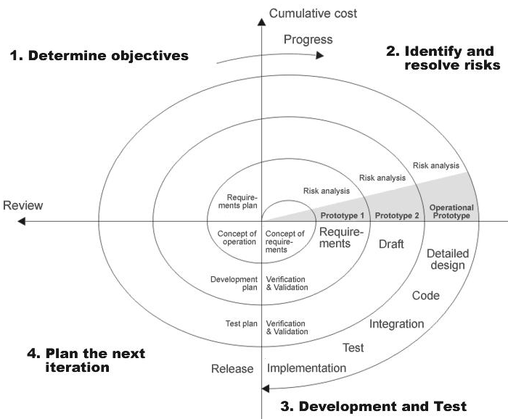

# 4.2. INTRODUCTION TO. NET

**The .NET Framework Architecture**

.NET Framework (pronounced dot net) is a software framework developed by Microsoft that runs primarily on Microsoft Windows. It includes a large class library known as Framework Class Library (FCL) and provides language interoperability (each language can use code written in other languages) across several programming languages. Programs written for the .NET Framework execute in a software environment (as contrasted to hardware environment), known as the Common Language Runtime (CLR), an application virtual machine that provides services such as security, memory management, and exception handling. FCL and the CLR together constitute .NET Framework.

FCL provides user interface, data access, database connectivity, cryptography, web application development, numeric algorithms, and network communications. Programmers produce sosoftware by combining their own source code with the .NET Framework and other libraries. .NET Framework is intended to be used by most new applications created for the Windows platform. Microsoft also produces an integrated development environment largely for .NET software called Visual Studio.

The first level of the representation is the operating system; the .NET layer is located between the system and applications. The second level is the Common Language Runtime (CLR), which provides the part of the .NET Framework doing the most work. We discuss the CLR later in this chapter. The next level is the Base Class Library (BCL), which provides all .NET objects that can be used both in your code and by Visual Basic when creating applications. The BCL also provides the infrastructure of several .NET technologies that you use in building applications, such as WPF, Windows Forms, ASP.NET, WCF, and so on. The last level is represented by applications that rely on the previous layers.

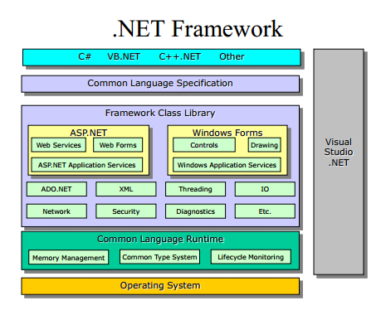

**Common Language Runtime engine**

Common Language Runtime (CLR) serves as the execution engine of the .NET Framework. All .NET programs execute under the supervision of the CLR, guaranteeing certain properties and behaviors in the areas of memory management, security, and exception handling.

**Language independence**

.NET Framework introduces a Common Type System, or CTS. The CTS specification defines all possible data types and programming constructs supported by the CLR and how they may or may not interact with each other conforming to the Common Language Infrastructure (CLI) specification. Because of this feature, the .NET Framework supports the exchange of types and object instances between libraries and applications written using any conforming.NET language.

**4.3 SQL SERVER 2014**

SQL is a relational database management system (RDBMS) that runs as a server providing multi-user access to a number of databases. It is a popular choice of database for the use in web applications and is an open source product.

The process of setting up a SQL database varies from host to host, however, we will end up with a database name, a user name and a password. Before using our database, we must create a table. A table is a section of the database for storing related information. In a table, we will set up the different fields that will be used. Creating a table is simple; we just have to type the name, select the number of fields and click the ‘go’ button.

We will then be taken to a setup screen where you must create the fields in the database.

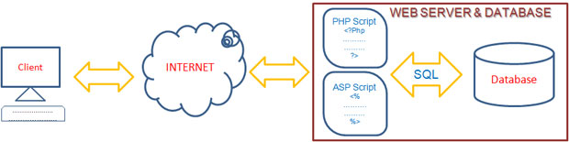

SQL is used to communicate with a database. According to ANSI (American National Standards Institute), it is the standard language for relational database management systems.

SQL statements are used to perform tasks such as update data on a database, or retrieve data from a database. Some common relational database management systems that use SQL are: Oracle, Sybase, Microsoft SQL Server, Access, Ingres, etc. Although most database systems use SQL, most of them also have their own additional proprietary extensions that are usually only used on their system. However, the standard SQL commands such as "Select", "Insert", "Update", "Delete", "Create", and "Drop" can be used to accomplish almost everything that one needs to do with a database.

Microsoft SQL Server is a relational database management system developed by Microsoft. As a database, it is a software product whose primary function is to store and retrieve data as requested by other software applications, be it those on the same computer or those running on another computer across a network (including the Internet).

SQL Server 2014 (formerly codenamed "Katmai") was released on August 6, 2014 and aims to make data management, self-tuning, self organizing, and self maintaining with the development of SQL Server Always On technologies, to provide near-zero downtime. SQL Server 2014 also includes support for structured and semi-structured data, including digital media formats for pictures, audio, video and other multimedia data. In current versions, such multimedia data can be stored as BLOBs (binary large objects), but they are generic bit streams. Intrinsic awareness of multimedia data will allow specialized functions to be performed on them. According to Paul Flessner, senior Vice President, Server, Applications, Microsoft Corp., SQL Server 2014 can be a data storage backend for different varieties of data: XML, email, time/calendar, file, document, spatial, etc as well as perform search, query, analysis, sharing, and synchronization across all data types.

**4.4. NORMALIZATION**

It is a process of converting a relation to a standard form. The process is used to handle the problems that can arise due to data redundancy, i.e. repetition of data in the database, maintain data integrity as well as handling problems that can arise due to insert, Update, delete anomalies.

Decomposing is the process of splitting relations into multiple relations to eliminate anomalies and maintain anomalies and maintain data integrity. To do this we use normal forms or rules for structuring relation.

**Insertion anomaly**: Inability to add data to the database due to absence of other data.

**Deletion anomaly**: Unintended loss of data due to deletion of other data.

**Update anomaly**: Data inconsistency resulting from data redundancy and partial update

**Normal Forms**: These are the rules for structuring relations that eliminate anomalies.

**FIRST NORMAL FORM:**

A relation is said to be in first normal form if the values in the relation are atomic for every attribute in the relation. By this we mean simply that no attribute value can be a set of values or, as it is sometimes expressed, a repeating group.

**SECOND NORMAL FORM:**

A relation is said to be in the second normal form is it is in first normal form and it should satisfy any one of the following rules.

* The primary key is a not a composite primary key
* No, non key attributes are present
* Every non key attribute is fully functionally dependent on a full set of primary key.

**THIRD NORMAL FORM:**

A relation is said to be in third normal form if their exits no transitive dependencies.

**Transitive Dependency**: If two non key attributes depend on each other as well as on the primary key, then they are said to be transitively dependent.

The above normalization principles were applied to decompose the data in multiple tables, thereby making the data to be maintained in a consistent state.

**TABLE DIAGRAM**

**MANAGER :**

|  |  |  |
| --- | --- | --- |
| LOGICAL NAME | DATA TYPE | DESCRIPTION |
| ID | INT | This is primary column, used to identify the row uniquely |
| NAME | VARCHAR(20) | Denotes the original name of the user |
| PHONE NO | INT | used to communicate with user |
| DOB | VARCHAR(20) | Denotes birth date of user |
| EMAIL | VARCHAR | Used to confirm the identity of a user |
| PROFILE PICTURE | IMAGE | Upload the user picture |
| ADDRESS | VARCHAR(50) | Denotes the address of user |
| PINCODE | INT | Denotes the pin code of user |
| PASSWORD | VARCHAR(50) | To confirm the identity of user |

**EMPLOYEE TABLE**

|  |  |  |
| --- | --- | --- |
| LOGICAL NAME | DATA TYPE | DESCRIPTION |
| ID | INT | This is primary column, used to identify the row uniquely |
| NAME | VARCHAR(20) | Denotes the original name of the user |
| PHONE NO | INT | used to communicate with user |
| DOB | VARCHAR(20) | Denotes birth date of user |
| EMAIL | VARCHAR | Used to confirm the identity of a user |
| PROFILE PICTURE | IMAGE | Upload the user picture |
| PASSWORD | VARCHAR(50) | To confirm the identity of user |

**4.5 SYSTEM ARCHITECTURE:**

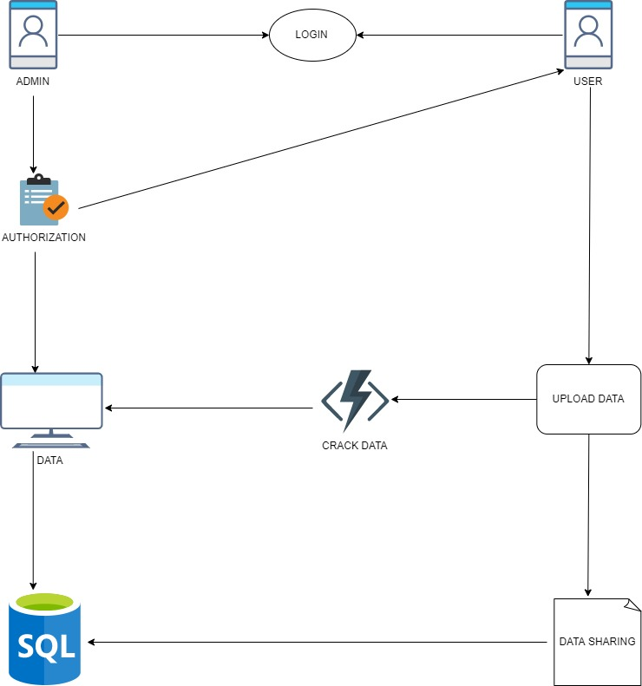

**4.6 MODULE DESCRIPTION**:

**ADMIN MODULE:**

The process of admin is to monitor each and every action in an organization and to proceed with the action in Admin. It allows system administrator to set up back-end of the system and perform basic system configuration, mainly definition of predefined drop-down fields, definition of classes time schedule, maintainability, authentication, etc. Part of the admin set up is users management which allows users to be set up with definable access level, access to a single or multiple branches. Admin can also set up overall system security settings such as required password strength, inactive session time out, inactive accounts lockout, a password reset period, etc. An important part of security is processed any changes in the system are logged here – so it’s easy to check who changed/removed what, at what time, what was the original value and what is the new value set.

**MANAGER MODULE:**

The manager module allows users to register, log in, and log out. They benefit from being able to sign on because these associates content they create with their account and allows various permissions to be set for their roles. The manager module supports user roles, which can be set up with fine-grained permissions allowing each role to do only what the administrator permits. Each user is assigned one or more roles. By default, there are three roles: anonymous (a user who has not logged in) and authenticated(a user who is registered), and administrator (a signed-in user who will be assigned site administrator permissions).

**EMPLOYEE MODULE:**

The employee is the actor added by the manager with certain terms. Once the employee has been added those details will be shown to the manager and the admin.they will be having complete information of the employee. The manager can able view only the persons who have been added and they will be given some task to performed by the manager. A complete information about the employees and managers will be shown only to the manager in their database.

**THIRD-PARTY MODULE :**

The third party is the one who will be getting some details of those employees and they will perform some actions in the localhost with the collection of those data. Without the knowledge of employees, they are going to make some changes in the application they are going to theft the data and gonna replace it with some other data without the knowledge of the employees. And those modified data will be shown only to the manager and the admin. Admin is the one has given the authority to handle those changed data in the database.so retrieving of data can be done only by the admin in this application.

AUTHORIZATION MODULE

In authorization the admin will be authorizing the manager in form of approval and decline the manager will be having registration once the manager registered the details will be shown to admin by this the admin will be authorizing the manager. once the admin declines the manager will not be able to login if admin approves the manager can able to login

PROFILE MODULE

In profile the manager can able to view the particular applicants who login in the application they can able view the id, designation and some other details. Where the admin can able to view the complete details.

ADD EMPLOYEE MODULE

The Employees module consists of various features allowing you to perform general management tasks such as **employee** history, perks and incident reports and all the forms and reports necessary to keep track of all your employee data, including age, certificates, personal details.. Any information needed is available at the click of a button with comprehensive reporting features.

**CHAPTER-5**

**RESULT ANALYSIS**

**5.1 COMPARISON CHART:**

Result analysis of our project describes how much it is efficient from existing projects

**TIME CONSUMPTION OF TABLE DIVISION:**

Attributes of Adult:

|  |  |
| --- | --- |
| **Attribute** | **Number of Distinct** |
| Age | **72** |
| Workclass | **7** |
| Education | **16** |
| Material | **7** |
| Occupation | **14** |
| Relationship | **6** |
| Race | **5** |

Attributes of Census-Income:

|  |  |
| --- | --- |
| **Attribute** | **Number of distinct** |
| Age | **91** |
| Worker | **9** |
| Industry | **52** |
| Education | **17** |
| Wage hour | **1240** |
| Major | **7** |
| Mace | **24** |

**CHAPTER-6**

**CONCLUSION AND FUTURE WORK**

The important goal of this work is to preserve the privacy of the multiple Sensitive data and to improve the utility of published data It discusses the analyzing approach in brief along with a comparison of its different values. Data analyzing is an efficient approach to the utility of published data with privacy to protect the privacy of published data which modifies the dataset to prevent sensitive information. This yields the means for the prevention of privacy threats like membership, identity and data disclosure. Also, this method can be used to operate for any number of Sensitive information in an efficient manner. In the future, the slicing of secured data with the flow of details is attacked and to reduce the time further through increased processor speed and memory with privacy.

**CHAPTER-7**

**APPENDIX**

**7.1 CODING:**

**ADMIN LOGIN CS:**

namespace WebApplication21

{

public partial class adminlogin : System.Web.UI.Page

{

string username ="admin";

string password ="admin@123";

protected void Page_Load(object sender, EventArgs e)

{

}

protected void Button1_Click(object sender, EventArgs e)

{

if(username==TextBox1.Text&& password==TextBox2.Text)

{

ScriptManager.RegisterStartupScript(this.Page, GetType(), "a", "alert('logged in successful')",true);

Response.Redirect("adminhome.aspx");

}

else

{

ScriptManager.RegisterStartupScript(this.Page, GetType(), "a", "alert('incorrect user name and password')",true);

}

}

}

}

**ADMIN LOGIN ASPX:**

<div class="login-agileits-top">

<label>User Name</label><asp:TextBox ID="TextBox1" runat="server" ></asp:TextBox><br />

<label>Password</label><asp:TextBox ID="TextBox2" runat="server" TextMode="Password" ></asp:TextBox><br />

<asp:Button ID="Button1" runat="server" Text="login" OnClick="Button1_Click" /><br />

</div>

**ADD EMPLOYEE ASPX:**

**<div class="banner-w3text">**

**<table border: 1px solid black;>**

**<tr>**

**<td>**

**<asp:Label ID="Label1" runat="server" Text="Employee name" align="left" ForeColor="white" style="color: #FFFFFF; background-color: none; text-decoration: none; font-size: large; font-weight: 200; font-style: oblique;"></asp:Label>**

**</td>**

**<td class="auto-style18">**

**&nbsp;&nbsp;&nbsp;&nbsp;&nbsp;&nbsp;&nbsp;&nbsp;&nbsp;&nbsp;&nbsp;&nbsp;&nbsp;&nbsp;&nbsp;&nbsp;&nbsp;&nbsp;&nbsp;&nbsp;&nbsp;&nbsp;&nbsp; <asp:TextBox ID="TextBox1" runat="server" CssClass="auto-style11" OnTextChanged="TextBox1_TextChanged" ></asp:TextBox>**

**<asp:RequiredFieldValidator ID="RequiredFieldValidator1" runat="server" ControlToValidate="TextBox1" ErrorMessage="Required"></asp:RequiredFieldValidator>**

**</td>**

**</tr>**

**<tr>**

**<td>**

**<asp:Label ID="Label2" runat="server" Text="Email" align="left" ForeColor="white" style="color: #FFFFFF; background-color: none; text-decoration: none; font-size: large; font-weight: 200; font-style: oblique;"></asp:Label>**

**</td>**

**<td class="auto-style18">**

**&nbsp; &nbsp; &nbsp; &nbsp;&nbsp;&nbsp;&nbsp;&nbsp;&nbsp;&nbsp;&nbsp;&nbsp;&nbsp;&nbsp;&nbsp;&nbsp;&nbsp;&nbsp;&nbsp;&nbsp;&nbsp; <asp:TextBox ID="TextBox2" runat="server" CssClass="auto-style9"></asp:TextBox>**

**<asp:RequiredFieldValidator ID="RequiredFieldValidator2" runat="server" ControlToValidate="TextBox2" ErrorMessage="Required"></asp:RequiredFieldValidator>**

**<asp:RegularExpressionValidator ID="RegularExpressionValidator1" runat="server" ControlToValidate="TextBox2" ErrorMessage="incorrect emailid" ValidationExpression="\w+([-+.']\w+)*@\w+([-.]\w+)*\.\w+([-.]\w+)*"></asp:RegularExpressionValidator>**

**</td>**

**</tr>**

**<tr>**

**<td>**

**<asp:Label ID="Label3" runat="server" Text="Phone No" ForeColor="white" style="color: #FFFFFF; background-color: none; text-decoration: none; font-size: large; font-weight: 200; font-style: oblique;"></asp:Label>**

**</td>**

**&nbsp; &nbsp; &nbsp; &nbsp;**

**<td class="auto-style18">**

**&nbsp;&nbsp;&nbsp;&nbsp;&nbsp;&nbsp;&nbsp;&nbsp;&nbsp;&nbsp;&nbsp;&nbsp;&nbsp;&nbsp;&nbsp;&nbsp;&nbsp;&nbsp;&nbsp;&nbsp;&nbsp;<asp:TextBox ID="TextBox3" runat="server" CssClass="auto-style10"></asp:TextBox>**

**<asp:RequiredFieldValidator ID="RequiredFieldValidator3" runat="server" ControlToValidate="TextBox3" ErrorMessage="Required"></asp:RequiredFieldValidator>**

**<asp:RegularExpressionValidator ID="RegularExpressionValidator2" runat="server" ControlToValidate="TextBox3" ErrorMessage="enter valid no" ValidationExpression="^([6789]{1})([0-9]{1})([0-9]{8})$"></asp:RegularExpressionValidator>**

**</td>**

**</tr>**

**<tr>**

**<td>**

**<asp:Label ID="Label4" runat="server" Text="Address" ForeColor="white" style="color: #FFFFFF; background-color: none; text-decoration: none; font-size: large; font-weight: 200; font-style: oblique;"></asp:Label>**

**</td>**

**<td class="auto-style18">**

**<asp:TextBox ID="TextBox4" runat="server" CssClass="auto-style12" OnTextChanged="TextBox4_TextChanged"></asp:TextBox>**

**<asp:RequiredFieldValidator ID="RequiredFieldValidator4" runat="server" ControlToValidate="TextBox4" ErrorMessage="Required"></asp:RequiredFieldValidator>**

**</td>**

**</tr>**

**<tr>**

**<td>**

**<asp:Label ID="Label5" runat="server" Text="Gender" ForeColor="white" style="color: #FFFFFF; background-color: none; text-decoration: none; font-size: large; font-weight: 200; font-style: oblique;"></asp:Label>**

**</td>**

**<td class="auto-style18">**

**<asp:RadioButton ID="RadioButton1" runat="server" Text="male" OnCheckedChanged="RadioButton1_CheckedChanged" ForeColor="White"></asp:RadioButton><asp:RadioButton ID="RadioButton2" runat="server" Text="female" ForeColor="White"></asp:RadioButton>**

**</td>**

**</tr>**

**<tr>**

**<td>**

**<asp:Label ID="Label6" runat="server" Text="Job" ForeColor="white" style="color: #FFFFFF; background-color: none; text-decoration: none; font-size: large; font-weight: 200; font-style: oblique;"></asp:Label>**

**</td>**

**<td class="auto-style18">**

**<asp:TextBox ID="TextBox5" runat="server" CssClass="auto-style13" OnTextChanged="TextBox5_TextChanged"></asp:TextBox>**

**<asp:RequiredFieldValidator ID="RequiredFieldValidator5" runat="server" ControlToValidate="TextBox5" ErrorMessage="Required"></asp:RequiredFieldValidator>**

**</td>**

**</tr>**

**<tr>**

**<td>**

**<asp:Label ID="Label7" runat="server" Text="Age" ForeColor="white" style="color: #FFFFFF; background-color: none; text-decoration: none; font-size: large; font-weight: 200; font-style: oblique;"></asp:Label>**

**</td>**

**<td class="auto-style18">**

**<asp:TextBox ID="TextBox6" runat="server" CssClass="auto-style14"></asp:TextBox>**

**<asp:RequiredFieldValidator ID="RequiredFieldValidator6" runat="server" ControlToValidate="TextBox6" ErrorMessage="Required" ></asp:RequiredFieldValidator>**

**</td>**

**</tr>**

**<tr>**

**<td>**

**<asp:Label ID="Label8" runat="server" Text="zipcode" ForeColor="white" style="color: #FFFFFF; background-color: none; text-decoration: none; font-size: large; font-weight: 200; font-style: oblique;"></asp:Label>**

**</td>**

**<td class="auto-style18">**

**<asp:TextBox ID="TextBox7" runat="server" CssClass="auto-style15" ></asp:TextBox>**

**<asp:RequiredFieldValidator ID="RequiredFieldValidator7" runat="server" ControlToValidate="TextBox7" ErrorMessage="Required"></asp:RequiredFieldValidator>**

**</td>**

**</tr>**

**<tr>**

**<td>**

**<asp:Label ID="Label9" runat="server" Text="Salary" ForeColor="white" style="color: #FFFFFF; background-color: none; text-decoration: none; font-size: large; font-weight: 200; font-style: oblique;"></asp:Label>**

**</td>**

**<td class="auto-style18">**

**<asp:TextBox ID="TextBox8" runat="server" OnTextChanged="TextBox8_TextChanged" CssClass="auto-style16"></asp:TextBox>**

**<asp:RequiredFieldValidator ID="RequiredFieldValidator8" runat="server" ControlToValidate="TextBox8" ErrorMessage="Required"></asp:RequiredFieldValidator>**

**</td>**

**</tr>**

**<tr>**

**<td>**

**<asp:Label ID="Label10" runat="server" Text="Company name" ForeColor="white" style="color: #FFFFFF; background-color: none; text-decoration: none; font-size: large; font-weight: 200; font-style: oblique;"></asp:Label>**

**</td>**

**<td class="auto-style18">**

**<asp:TextBox ID="TextBox9" runat="server" CssClass="auto-style17"></asp:TextBox>**

**<asp:RequiredFieldValidator ID="RequiredFieldValidator9" runat="server" ControlToValidate="TextBox9" ErrorMessage="Required"></asp:RequiredFieldValidator>**

**</td>**

**</tr>**

**<tr>**

**<td>**

**<asp:Label ID="Label11" runat="server" Text="Diesease" ForeColor="white" style="color: #FFFFFF; background-color: none; text-decoration: none; font-size: large; font-weight: 200; font-style: oblique;"></asp:Label>**

**</td>**

**<td class="auto-style18">**

**<asp:TextBox ID="TextBox10" runat="server" CssClass="auto-style6"></asp:TextBox>**

**<asp:RequiredFieldValidator ID="RequiredFieldValidator10" runat="server" ControlToValidate="TextBox10" ErrorMessage="Required"></asp:RequiredFieldValidator>**

**</td>**

**</tr>**

**<tr>**

**<td>**

**<asp:Label ID="Label12" runat="server" Text="Profile picture" ForeColor="white" style="color: #FFFFFF; background-color: none; text-decoration: none; font-size: large; font-weight: 200; font-style: oblique;"></asp:Label>**

**</td>**

**<td class="auto-style18">**

**<asp:FileUpload ID="FileUpload1" runat="server" ForeColor="White" CssClass="auto-style2"></asp:FileUpload>**

**<br />**

**</td>**

**</tr>**

**<tr>**

**<td>**

**<asp:Label ID="Label13" runat="server" Text="Reporting to" ForeColor="white" style="color: #FFFFFF; background-color: none; text-decoration: none; font-size: large; font-weight: 200; font-style: oblique;"></asp:Label>**

**</td>**

**<td class="auto-style18">**

**<asp:TextBox ID="TextBox11" runat="server" CssClass="auto-style8"></asp:TextBox>**

**</td>**

**</tr>**

**</table>**

**<br />**

**<br />**

**<asp:Button ID="Button1" runat="server" Text="Submit" OnClick="Button1_Click"></asp:Button>**

**<%--<h4>Curabitur sagittis ultrices</h4>**

**<h2>Quisque nunc quisenim ullam</h2>**

**<h5>Donec massa ipsum imperdiet </h5>**

**<a href="single.html" class="w3btn"><span>Read More</span></a>--%>**

**</div>**

**ADD EMPLOYEE CS:**

: System.Web.UI.Page

{

SqlConnection con = new SqlConnection(@"Data Source=LAPTOP-IR22HST4\SQLEXPRESS;Database=company;Integrated security=true");

protected void Page_Load(object sender, EventArgs e)

{

}

protected void RadioButton1_CheckedChanged(object sender, EventArgs e)

{

string rb;

if (RadioButton1.Checked == true)

{

rb = "male";

}

else

{

rb = "female";

}

}

protected void Button1_Click(object sender, EventArgs e)

{

string rb;

if (RadioButton1.Checked == true)

{

rb = "male";

}

else

{

rb = "female";

}

string pic = FileUpload1.FileName;

SqlConnection con = new SqlConnection(@"Data source=LAPTOP-IR22HST4\SQLEXPRESS;database=company;integrated security=true");

con.Open();

SqlCommand cmd = new SqlCommand("insert into addemp values('" + TextBox1.Text + "','" + TextBox2.Text + "','" + TextBox3.Text + "','" + TextBox4.Text + "','" + rb + "','" + TextBox5.Text + "','" + TextBox6.Text + "','" + TextBox7.Text + "','" + TextBox8.Text + "','" + TextBox9.Text + "','" + TextBox10.Text + "','" + pic + "','attack not found','" + TextBox11.Text + "')", con);

cmd.ExecuteNonQuery();

SqlCommand cmd1 = new SqlCommand("insert into retrive values('" + TextBox1.Text + "','" + TextBox2.Text + "','" + TextBox3.Text + "','" + TextBox4.Text + "','" + rb + "','" + TextBox5.Text + "','" + TextBox6.Text + "','" + TextBox7.Text + "','" + TextBox8.Text + "','" + TextBox9.Text + "','" + TextBox10.Text + "','" + pic + "','attack not found','" + TextBox11.Text + "')", con);

cmd1.ExecuteNonQuery();

ScriptManager.RegisterStartupScript(this.Page, GetType(), "a", "alert('registered successfully')", true);

con.Close();

Response.Redirect("managerhome.aspx");

}

protected void TextBox8_TextChanged(object sender, EventArgs e)

{

}

protected void TextBox1_TextChanged(object sender, EventArgs e)

{

}

protected void TextBox5_TextChanged(object sender, EventArgs e)

{

}

protected void TextBox4_TextChanged(object sender, EventArgs e)

{

}

}

**PROFILE CS:**

<table style="border: double outset #FFFFFF">

<tr>

<td class="auto-style1">

<%-- <label id="t" runat="server" Text="Label" Width="300px" Height="45px" ForeColor="White" style="color: #000000; background-color: #FFFFFF">Name</label>--%>

<asp:Label ID="Label7" runat="server" Text="Name" Width="300px" Height="45px" ForeColor="White" style="color: #FFFFFF; background-color: none; text-decoration: none; font-size: large; font-weight: 200; font-style: oblique;"></asp:Label>

</td>

<td>

<asp:Label ID="Label1" runat="server" Text="Label" Width="300px" Height="45px" ForeColor="White" style="color: #FFFFFF; background-color: none; text-decoration: none; font-size: large; font-weight: 200; font-style: oblique;"></asp:Label>

</td>

</tr>

<tr>

<td class="auto-style1">

<label id="i" runat="server" Text="Label" Width="300px" Height="45px" ForeColor="White" style="color: #FFFFFF; background-color: none; text-decoration: none; font-size: large; font-weight: 200; font-style: oblique;" >Email</label>

</td>

<td>

<asp:Label ID="Label2" runat="server" Text="Label" Width="300px" Height="45px" ForeColor="White" style="color: #FFFFFF; background-color: none; text-decoration: none; font-size: large; font-weight: 200; font-style: oblique;"></asp:Label>

</td>

</tr>

<tr>

<td>

<label id="j" runat="server" Text="Label" Width="300px" Height="45px" ForeColor="White" style="color: #FFFFFF; background-color: none; text-decoration: none; font-size: large; font-weight: 200; font-style: oblique;">Phone No</label>

</td>

<td>

<asp:Label ID="Label3" runat="server" Text="Label" Width="300px" Height="45px" ForeColor="White" style="color: #FFFFFF; background-color: none; text-decoration: none; font-size: large; font-weight: 200; font-style: oblique;"></asp:Label>

</td>

</tr>

<tr>

<td>

<label id="o" runat="server" Text="Label" Width="300px" Height="45px" ForeColor="White" style="color: #FFFFFF; background-color: none; text-decoration: none; font-size: large; font-weight: 200; font-style: oblique;">Address</label>

</td>

<td>

<asp:Label ID="Label4" runat="server" Text="Label" Width="300px" Height="45px" ForeColor="White" style="color: #FFFFFF; background-color: none; text-decoration: none; font-size: large; font-weight: 200; font-style: oblique;"></asp:Label>

</td>

</tr>

<tr>

<td>

<label id="w" runat="server" Text="Label" Width="300px" Height="45px" ForeColor="White" style="color: #FFFFFF; background-color: none; text-decoration: none; font-size: large; font-weight: 200; font-style: oblique;">Dob</label>

</td>

<td>

<asp:Label ID="Label5" runat="server" Text="Label" Width="300px" Height="45px" ForeColor="White" style="color: #FFFFFF; background-color: none; text-decoration: none; font-size: large; font-weight: 200; font-style: oblique;"></asp:Label>

</td>

</tr>

<tr>

<td>

<label id="h" runat="server" Text="Label" Width="300px" Height="45px" ForeColor="White" style="color: #FFFFFF; background-color: none; text-decoration: none; font-size: large; font-weight: 200; font-style: oblique;">Status</label>

</td>

<td>

<asp:Label ID="Label6" runat="server" Text="Label" Width="300px" Height="45px" ForeColor="White" style="color: #FFFFFF; background-color: none; text-decoration: none; font-size: large; font-weight: 200; font-style: oblique;"></asp:Label>

</td>

</tr>

</table>

**PROFILE CS:**

{

// string email;

string name;

SqlConnection con = new SqlConnection(@"Data Source=LAPTOP-IR22HST4\SQLEXPRESS;database=company;Integrated security=true");

protected void Page_Load(object sender, EventArgs e)

{

name = Session["name"].ToString();

con.Open();

SqlCommand cmd = new SqlCommand("select * from userre where name='"+name+"'",con);

SqlDataReader dr = cmd.ExecuteReader();

if(dr.Read())

{

name = dr.GetValue(0).ToString();

Label1.Text = name;

Label2.Text = dr.GetString(2).ToString();

Label3.Text = dr.GetString(3).ToString();

Label4.Text = dr.GetString(4).ToString();

Label5.Text = dr.GetString(6).ToString();

Label6.Text = dr.GetString(8).ToString();

}

con.Close();

}

**REGISTRATION ASPX:**

<div class="w3ls-main">

<div class="w3ls-form">

<table>

<tr>

<td>

<div class="w3ls-name">

<label class="w3ls-opt">Name<span class="w3ls-star"> *

</span></label>

</div>

</td>

<td>

<asp:TextBox ID="TextBox1" runat="server"></asp:TextBox> <asp:RequiredFieldValidator ID="RequiredFieldValidator1" runat="server" ControlToValidate="TextBox1" ErrorMessage="Required"></asp:RequiredFieldValidator>

</td>

</tr>

<tr>

<td>

<label class="w3ls-opt">Password<span class="w3ls-star"> *

</span></label>

<span class="w3ls-text w3ls-name">

</span>

</td>

<td>

<asp:TextBox ID="TextBox2" runat="server" TextMode="Password" CssClass="jj" ></asp:TextBox><asp:RequiredFieldValidator ID="RequiredFieldValidator2" runat="server" ControlToValidate="TextBox2" ErrorMessage="Required"></asp:RequiredFieldValidator>

</td>

</tr>

<tr>

<td>

<label class="w3ls-opt">EMAIL<span class="w3ls-star"> * </span></label>

<span class="w3ls-text w3ls-name">

</span>

</td>

<td>

<asp:TextBox ID="TextBox3" runat="server"></asp:TextBox> <asp:RequiredFieldValidator ID="RequiredFieldValidator3" runat="server" ControlToValidate="TextBox3" ErrorMessage="Required"></asp:RequiredFieldValidator>

<asp:RegularExpressionValidator ID="RegularExpressionValidator2" runat="server" ControlToValidate="TextBox3" ErrorMessage="Regular" ValidationExpression="\w+([-+.']\w+)*@\w+([-.]\w+)*\.\w+([-.]\w+)*"></asp:RegularExpressionValidator>

</td>

</tr>

<tr>

<td>

<label class="w3ls-opt">Phone no<span class="w3ls-star"> * </span></label>

<span class="w3ls-text w3ls-name">

</span>

</td>

<td>

<asp:TextBox ID="TextBox4" runat="server"></asp:TextBox> <asp:RegularExpressionValidator ID="RegularExpressionValidator1" runat="server" ControlToValidate="TextBox4" ErrorMessage="Regular" ValidationExpression="^([6789]{1})([0-9]{1})([0-9]{8})$"></asp:RegularExpressionValidator>

<asp:RequiredFieldValidator ID="RequiredFieldValidator4" runat="server" ControlToValidate="TextBox4" ErrorMessage="Required"></asp:RequiredFieldValidator>

</td>

</tr>

<tr>

<td>

<label class="w3ls-opt">Address <span class="w3ls-star"> * </span> </label>

<span class="w3ls-text w3ls-name">

</span>

</td>

<td>

<asp:TextBox ID="TextBox5" runat="server"></asp:TextBox> <asp:RequiredFieldValidator ID="RequiredFieldValidator5" runat="server" ControlToValidate="TextBox5" ErrorMessage="Required"></asp:RequiredFieldValidator>

</td>

</tr>

<tr>

<td>

<label class="w3ls-opt">Pincode <span class="w3ls-star"> * </span> </label>

<span class="w3ls-text w3ls-name">

</span>

</td>

<td>

<asp:TextBox ID="TextBox6" runat="server"></asp:TextBox> <asp:RequiredFieldValidator ID="RequiredFieldValidator6" runat="server" ControlToValidate="TextBox6" ErrorMessage="Required"></asp:RequiredFieldValidator>

</td>

</tr>

<tr>

<td>

<label class="w3ls-opt">Dob<span class="w3ls-star"> * </span></label>

<span class="w3ls-text w3ls-name">

</span>

</td>

<td>

<asp:TextBox ID="TextBox7" runat="server" TextMode="Date" CssClass="jj"></asp:TextBox>

</td>

</tr>

<tr>

<td>

<label class="w3ls-opt">profile picture<span class="w3ls-star"> * </span></label>

<span class="w3ls-text w3ls-name">

</span>

</td>

<td>

<asp:FileUpload ID="FileUpload1" runat="server" CssClass="jj" /> <asp:RequiredFieldValidator ID="RequiredFieldValidator7" runat="server" ControlToValidate="FileUpload1" ErrorMessage="Required"></asp:RequiredFieldValidator>

</td>

</tr>

</table>

<div class="clear"></div>

<div align="center">

<asp:Button ID="Button1" runat="server" Text="Register" OnClick="Button1_Click" CssClass="f" />

</div>

</div>

</div>

**REGISTRATION CS:**

protected void Button1_Click(object sender, EventArgs e)

{

string pic = FileUpload1.FileName;

SqlConnection con = new SqlConnection(@"Data source=LAPTOP-IR22HST4\SQLEXPRESS;database=company;integrated security=true");

con.Open();

SqlCommand cmd = new SqlCommand("insert into userre values('"+TextBox1.Text+"','"+TextBox2.Text+"','"+TextBox3.Text+"','"+TextBox4.Text+"','"+TextBox5.Text+"','"+TextBox6.Text+"','"+TextBox7.Text+"','"+pic+"','pending')",con);

cmd.ExecuteNonQuery();

ScriptManager.RegisterStartupScript(this.Page,GetType(),"a","alert('successfull')",true);

con.Close();

Response.Redirect("userlogin.aspx");

}

**USER LOGIN:**

<div class="login-agileits-top">

<label>User Name</label><asp:TextBox ID="TextBox1" runat="server"></asp:TextBox><br />

<label>Password</label><asp:TextBox ID="TextBox2" runat="server"></asp:TextBox><br />

<asp:Button ID="Button1" runat="server" Text="login" OnClick="Button1_Click" /><br />

<asp:Button ID="Button2" runat="server" Text="Register Now" OnClick="Button2_Click" />

</div>

**USER LOGIN CS:**

Session["name"] = TextBox1.Text;

SqlConnection con = new SqlConnection(@"Data Source=LAPTOP-IR22HST4\SQLEXPRESS;Database=company;integrated security=true");

con.Open();

SqlCommand cmd = new SqlCommand("select * from userre where name='" + TextBox1.Text + "'and passwords='" + TextBox2.Text + "'", con);

SqlDataReader dr = cmd.ExecuteReader();

if (dr.Read())

{

string status = dr.GetString(8).ToString();

if (status == "Approved")

{

ScriptManager.RegisterStartupScript(this.Page, GetType(), "a", "alert('welcome')", true);

Response.Redirect("managerhome.aspx");

}

else

{

ScriptManager.RegisterStartupScript(this.Page, GetType(), "aaa", "alert('your account declined')", true);

}

}

}

protected void Button2_Click(object sender, EventArgs e)

{

Response.Redirect("registration.aspx");

}

**VIEW EMPLOYEE CS:**

{

SqlConnection con = new SqlConnection(@"Data Source=LAPTOP-IR22HST4\SQLEXPRESS;Database=company;Integrated security=true");

con.Open();

SqlCommand cmd = new SqlCommand("select * from addemp", con);

SqlDataAdapter da = new SqlDataAdapter(cmd);

DataTable dt = new DataTable();

da.Fill(dt);

GridView1.DataSource = dt;

GridView1.DataBind();

con.Close();

// var example = "\"Quoted Value with spaces and &\"";

}

**VIEW EMPLOYEE ASPX:**

<div class="banner-w3text">

<h2>view all employee </h2>

<asp:GridView ID="GridView1" runat="server" AutoGenerateColumns="false" BackColor="White" BorderColor="#999999" BorderStyle="None" BorderWidth="1px" CellPadding="3" GridLines="Vertical">

<AlternatingRowStyle BackColor="#DCDCDC" />

<Columns>

<asp:BoundField DataField="name" HeaderText="Name" SortExpression="name" />

<asp:BoundField DataField="email" HeaderText="Email" SortExpression="email" />

<asp:BoundField DataField="phoneno" HeaderText="Phoneno" SortExpression="phoneno" />

<asp:BoundField DataField="addresss" HeaderText="Addresss" SortExpression="addresss" />

<asp:BoundField DataField="gender" HeaderText="Gender" SortExpression="gender" />

<asp:BoundField DataField="job" HeaderText="Job" SortExpression="job" />

<asp:BoundField DataField="age" HeaderText="Age" SortExpression="age" />

<asp:BoundField DataField="zipcode" HeaderText="Zipcode" SortExpression="zipcode" />

<asp:BoundField DataField="salary" HeaderText="Salary" SortExpression="salary" />

<asp:BoundField DataField="companyname" HeaderText="CompanyName" SortExpression="companyname" />

<asp:BoundField DataField="disease" HeaderText="Disease" SortExpression="disease" />

<asp:BoundField DataField="empimg" HeaderText="Empimg" SortExpression="empimg" />

<asp:BoundField DataField="reportingto" HeaderText="ReportingTo" SortExpression="reportingto" />

</Columns>

<FooterStyle BackColor="#CCCCCC" ForeColor="Black" />

<HeaderStyle BackColor="#000084" Font-Bold="True" ForeColor="White" />

<PagerStyle BackColor="#999999" ForeColor="Black" HorizontalAlign="Center" />

<RowStyle BackColor="#EEEEEE" ForeColor="Black" />

<SelectedRowStyle BackColor="#008A8C" Font-Bold="True" ForeColor="White" />

<SortedAscendingCellStyle BackColor="#F1F1F1" />

<SortedAscendingHeaderStyle BackColor="#0000A9" />

<SortedDescendingCellStyle BackColor="#CAC9C9" />

<SortedDescendingHeaderStyle BackColor="#000065" />

</asp:GridView>

<%--<h4>Curabitur sagittis ultrices</h4>

<h2>Quisque nunc quisenim ullam</h2>

<h5>Donec massa ipsum imperdiet </h5>

<a href="single.html" class="w3btn"><span>Read More</span></a>--%>

</div>

</div>

**VIEW ATTACKERS CS:**

protected void Page_Load(object sender, EventArgs e)

{

SqlConnection con = new SqlConnection(@"Data Source=LAPTOP-IR22HST4\SQLEXPRESS;Database=company;Integrated security=true");

con.Open();

SqlCommand cmd = new SqlCommand("select* from addemp", con);

SqlDataAdapter da = new SqlDataAdapter(cmd);

DataTable dt = new DataTable();

da.Fill(dt);

GridView1.DataSource = dt;

GridView1.DataBind();

con.Close();

}

**VIEW ATTACKERS ASPX:**

**<%@ Page Language="C#" AutoEventWireup="true" CodeBehind="viewattackeruser.aspx.cs" Inherits="WebApplication21.viewattackeruser" %>**

**<!DOCTYPE html>**

**<html lang="en">**

**<head>**

**<title>Focus a Corporate Category Flat Bootstrap Responsive website Template | Home :: w3layouts</title>**

**<meta name="viewport" content="width=device-width, initial-scale=1">**

**<meta http-equiv="Content-Type" content="text/html; charset=utf-8" />**

**<meta name="keywords" content="Focus Responsive web template, Bootstrap Web Templates, Flat Web Templates, Android Compatible web template,**

**SmartPhone Compatible web template, free WebDesigns for Nokia, Samsung, LG, Sony Ericsson, Motorola web design" />**

**<script type="application/x-javascript"> addEventListener("load", function() { setTimeout(hideURLbar, 0); }, false); function hideURLbar(){ window.scrollTo(0,1); } </script>**

**<!-- Custom Theme files -->**

**<link href="managerhome/css/bootstrap.css" type="text/css" rel="stylesheet" media="all">**

**<link href="managerhome/css/style.css" type="text/css" rel="stylesheet" media="all">**

**<link href="managerhome/css/font-awesome.css" rel="stylesheet"> <!-- font-awesome icons -->**

**<link rel="stylesheet" href="managerhomecss/flexslider.css" type="text/css" media="screen" />**

**<!-- //Custom Theme files -->**

**<!-- js -->**

**<script src="managerhome/js/jquery-2.2.3.min.js"></script>**

**<!-- //js -->**

**<!-- web-fonts -->**

**<link href="//fonts.googleapis.com/css?family=Open+Sans:300,300i,400,400i,600,600i,700,700i,800,800i" rel="stylesheet">**

**<link href="//fonts.googleapis.com/css?family=Open+Sans+Condensed:300,300i,700" rel="stylesheet">**

**<!-- //web-fonts -->**

**<style type="text/css">**

**.auto-style1 {**

**height: 44px;**

**}**

**.auto-style2 {**

**height: 65px;**

**}**

**.auto-style3 {**

**width: 94px;**

**}**

**.auto-style4 {**

**width: 19px;**

**}**

**</style>**

**</head>**

**<body>**

**<form id="yu" runat="server">**

**<!-- banner -->**

**<div class="banner-w3layouts">**

**<div class="flexslider">**

**<ul class="slides">**

**<li>**

**<div class="banner-img1">**

**</div>**

**</li>**

**<%--<li>**

**<div class="banner-img2">**

**</div>**

**</li>--%>**

**</ul>**

**</div>**

**<!-- FlexSlider -->**

**<script defer src="js/jquery.flexslider.js"></script>**

**<script type="text/javascript">**

**$(window).load(function(){**

**$('.flexslider').flexslider({**

**animation: "slide",**

**start: function(slider){**

**$('body').removeClass('loading');**

**}**

**});**

**});**

**</script>**

**<!-- //FlexSlider -->**

**<!-- banner-info -->**

**<div class="banner-agileinfo">**

**<div class="container">**

**<div class="w3header"> <!--header-->**

**<nav class="navbar navbar-default">**

**<div class="navbar-header">**

**<button type="button" class="navbar-toggle" data-toggle="collapse" data-target="#bs-example-navbar-collapse-1">**

**<span class="sr-only">Toggle navigation</span>**

**<span class="icon-bar"></span>**

**<span class="icon-bar"></span>**

**<span class="icon-bar"></span>**

**</button>**

**<h1><a href="index.html">MANAGER</a></h1>**

**</div>**

**<!-- navbar-header -->**

**<div class="collapse navbar-collapse" id="bs-example-navbar-collapse-1">**

**<%--<form class="navbar-right w3ls-search" action="#" method="post">**

**<input type="search" name="Search" placeholder="Enter your text..." required="">**

**<button type="submit" class="btn btn-default" aria-label="Left Align">**

**<span class="glyphicon glyphicon-search"></span>**

**</button>**

**</form>--%>**

**<ul class="nav navbar-nav navbar-right">**

**<li><a href="profile.aspx">PROFILE</a></li>**

**<li><a href="addemployee.aspx">ADD EMPLOYEE</a></li>**

**<li><a href="viewallemployee.aspx">VIEW EMPLOYEE</a></li>**

**<li><a href="viewattackeruser.aspx">VIEW ATTACKERS</a></li>**

**<li><a href="home.aspx">LOG OUT</a></li>**

**</ul>**

**<div class="clearfix"> </div>**

**</div>**

**</nav>**

**</div>**

**<!-- //header -->**

**<div class="banner-w3text">**

**<asp:Label ID="Label1" runat="server" Text="VIEW ATTACKER" ForeColor="White"></asp:Label>**

**<asp:GridView ID="GridView1" runat="server" BackColor="White" BorderColor="#999999" BorderStyle="None" BorderWidth="1px" CellPadding="3" GridLines="Vertical">**

**<AlternatingRowStyle BackColor="#DCDCDC" />**

**<FooterStyle BackColor="#CCCCCC" ForeColor="Black" />**

**<HeaderStyle BackColor="#000084" Font-Bold="True" ForeColor="White" />**

**<PagerStyle BackColor="#999999" ForeColor="Black" HorizontalAlign="Center" />**

**<RowStyle BackColor="#EEEEEE" ForeColor="Black" />**

**<SelectedRowStyle BackColor="#008A8C" Font-Bold="True" ForeColor="White" />**

**<SortedAscendingCellStyle BackColor="#F1F1F1" />**

**<SortedAscendingHeaderStyle BackColor="#0000A9" />**

**<SortedDescendingCellStyle BackColor="#CAC9C9" />**

**<SortedDescendingHeaderStyle BackColor="#000065" />**

**</asp:GridView>**

**<%--<h4>Curabitur sagittis ultrices</h4>**

**<h2>Quisque nunc quisenim ullam</h2>**

**<h5>Donec massa ipsum imperdiet </h5>**

**<a href="single.html" class="w3btn"><span>Read More</span></a>--%>**

**</div>**

**</div>**

**<!-- //banner-info -->**

**</div>**

**</div>**

**<!-- //banner -->**

**<!-- welcome -->**

**<%--<div class="welcome">**

**<div class="container">**

**<div class="agileits-title">**

**<h3>Welcome To Focus</h3>**

**<p>Mauris rutrum turpis eget tincidunt eleifend vestibulum condimentum mollis tellus eu magna laoreet.</p>**

**</div>**

**<div class="welcome-agileinfo">**

**<div class="col-md-4 col-xs-6 welcome-grid agileits-w3layouts">**

**<div class="col-xs-2 welcome-grid-left">**

**<span class="glyphicon glyphicon-briefcase" aria-hidden="true"></span>**

**</div>**

**<div class="col-xs-10 welcome-grid-right">**

**<h4>tiamet pharetra nunc </h4>**

**<p>Itaque earum rerum hic tenetur a sapiente delectus maiores alias phasellus</p>**

**</div>**

**<div class="clearfix"> </div>**

**</div>**

**<div class="col-md-4 col-xs-6 welcome-grid agileits-w3layouts">**

**<div class="col-xs-2 welcome-grid-left">**

**<span class="glyphicon glyphicon-heart" aria-hidden="true"></span>**

**</div>**

**<div class="col-xs-10 welcome-grid-right">**

**<h4>Etiam pharetra</h4>**

**<p>Sapiente delectus reiciendis maiores alias phasellus mattis tellus dictum </p>**

**</div>**

**<div class="clearfix"> </div>**

**</div>**

**<div class="col-md-4 col-xs-6 welcome-grid agileits-w3layouts">**

**<div class="col-xs-2 welcome-grid-left">**

**<span class="glyphicon glyphicon-check" aria-hidden="true"></span>**

**</div>**

**<div class="col-xs-10 welcome-grid-right">**

**<h4>pharetra erat</h4>**

**<p>phasellus mattis tellus eget tellus dictum justo scelerisque eget sapiente </p>**

**</div>**

**<div class="clearfix"> </div>**

**</div>**

**<div class="col-md-4 col-xs-6 welcome-grid welcome-grid-bottom">**

**<div class="col-xs-2 welcome-grid-left">**

**<span class="glyphicon glyphicon-list-alt" aria-hidden="true"></span>**

**</div>**

**<div class="col-xs-10 welcome-grid-right">**

**<h4>erat et nunc </h4>**

**<p>Maiores alias phasellus mattis tellus eget tellus dictum justo interdum </p>**

**</div>**

**<div class="clearfix"> </div>**

**</div>**

**<div class="col-md-4 col-xs-6 welcome-grid welcome-grid-bottom">**

**<div class="col-xs-2 welcome-grid-left">**

**<span class="glyphicon glyphicon-hourglass" aria-hidden="true"></span>**

**</div>**

**<div class="col-xs-10 welcome-grid-right">**

**<h4>tiamet pharetra nunc </h4>**

**<p>Itaque earum rerum hic tenetur a sapiente delectus maiores alias phasellus</p>**

**</div>**

**<div class="clearfix"> </div>**

**</div>**

**<div class="col-md-4 col-xs-6 welcome-grid welcome-grid-bottom">**

**<div class="col-xs-2 welcome-grid-left">**

**<span class="glyphicon glyphicon-time" aria-hidden="true"></span>**

**</div>**

**<div class="col-xs-10 welcome-grid-right">**

**<h4>Etiam pharetra</h4>**

**<p>Sapiente delectus reiciendis maiores alias phasellus mattis tellus dictum </p>**

**</div>**

**<div class="clearfix"> </div>**

**</div>**

**<div class="clearfix"> </div>**

**</div>--%>**

**</div>**

**</div>--%>**

**<!-- //welcome -->**

**<!-- about-slid -->**

**<%--<div class="w3about-slid agileits-w3layouts">**

**<div class="container">**

**<div class="about-slid-info">**

**<h4>Lorem ipsum dolor sit amet consectetur</h4>**

**<p>Fusce eu semper lacus, eget placerat mauris. Sed lectus tellus, sodales id elit a, feugiat porttitor nulla. Sed porta magna vitae nisl vulputate lacinia. Morbi malesuada sollicitudin tortor, vitae pharetra nunc lacinia eget.</p>**

**</div>**

**</div>**

**</div>--%>**

**<!-- //about-slid -->**

**<!-- skills -->**

**<%--<div class="skills w3-agileits">**

**<div class="container">**

**<div class="skills-agileinfo">**

**<div class="col-md-6 skills-w3left">**

**<h4>Our Services</h4>**

**<div class="bs-example bs-example-tabs" role="tabpanel" data-example-id="togglable-tabs">**

**<ul id="myTab" class="nav nav-tabs" role="tablist">**

**<li role="presentation" class="active"><a href="#home" id="home-tab" role="tab" data-toggle="tab" aria-controls="home" aria-expanded="true">Service1</a></li>**

**<li role="presentation"><a href="#carl" role="tab" id="carl-tab" data-toggle="tab" aria-controls="carl">Service2</a></li>**

**<li role="presentation"><a href="#james" role="tab" id="james-tab" data-toggle="tab" aria-controls="james">Service3</a></li>**

**</ul>**

**<div id="myTabContent" class="tab-content">**

**<div role="tabpanel" class="tab-pane fade in active" id="home" aria-labelledby="home-tab">**

**<div class="tabcontent-grids">**

**<p>Lorem ipsum dolor sit amet, consectetur adipiscing elit. Sed tincidunt lorem sed velit fermentum lobortis. Fusce eu semper lacus, eget placerat mauris. Sed lectus tellus, sodales id elit a, feugiat porttitor nulla. Sed porta magna vitae nisl vulputate lacinia. Morbi malesuada sollicitudin tortor, vitae pharetra nunc lacinia eget. Nulla ornare purus nunc, ut dapibus leo sodales adipiscing. </p>**

**</div>**

**</div>**

**<div role="tabpanel" class="tab-pane fade" id="carl" aria-labelledby="carl-tab">**

**<div class="tabcontent-grids">**

**<ul>**

**<li><span class="glyphicon glyphicon-menu-right"></span> Sed tincidunt lorem sed </li>**

**<li><span class="glyphicon glyphicon-menu-right"></span> Excepteur sint occaecat </li>**

**<li><span class="glyphicon glyphicon-menu-right"></span> Duis aute irure dolor in </li>**

**<li><span class="glyphicon glyphicon-menu-right"></span> Sed tincidunt lorem sed </li>**

**<li><span class="glyphicon glyphicon-menu-right"></span> Excepteur sint occaecat </li>**

**<li><span class="glyphicon glyphicon-menu-right"></span> Duis aute irure dolor in </li>**

**</ul>**

**</div>**

**</div>**

**<div role="tabpanel" class="tab-pane fade" id="james" aria-labelledby="james-tab">**

**<div class="tabcontent-grids">**

**<ul>**

**<li><span class="glyphicon glyphicon-menu-right"></span> Sed tincidunt lorem sed </li>**

**<li><span class="glyphicon glyphicon-menu-right"></span> Excepteur sint occaecat </li>**

**<li><span class="glyphicon glyphicon-menu-right"></span> Duis aute irure dolor in </li>**

**<li><span class="glyphicon glyphicon-menu-right"></span> Sed tincidunt lorem sed </li>**

**<li><span class="glyphicon glyphicon-menu-right"></span> Excepteur sint occaecat </li>**

**<li><span class="glyphicon glyphicon-menu-right"></span> Duis aute irure dolor in </li>**

**</ul>**

**</div>**

**</div>**

**</div>**

**</div>**

**</div>**

**<h4>Our Specialization</h4>**

**<div class="col-md-6 skills-w3right bar_group">**

**<div class='bar_group__bar thin' label='Lorem ipsum &nbsp;&nbsp; 80%' value='200'></div>**

**<div class='bar_group__bar thin' label='Quis nostrud &nbsp;&nbsp; 100%' value='250'></div>**

**<div class='bar_group__bar thin' label='Sed do eiusmod &nbsp;&nbsp; 72%' value='180'></div>**

**<div class='bar_group__bar thin' label='Ut enim adnim &nbsp;&nbsp; 88%' value='220'></div>**

**</div>**

**<!-- bar-js -->**

**<script src="js/bars.js"></script>**

**<!-- bar-js -->**

**<div class="clearfix"> </div>**

**</div>**

**</div>**

**</div>--%>**

**<!-- //skills -->**

**<!-- news -->**

**<%--<div class="news-w3layouts">**

**<div class="container">**

**<div class="agileits-title">**

**<h3>News & Events</h3>**

**<p>Mauris rutrum turpis eget tincidunt eleifend vestibulum condimentum mollis tellus eu magna laoreet.</p>**

**</div>**

**<div class="news-agileinfo w3-agileits">**

**<div class="col-md-4 news-w3lgrids">**

**<h4><span>13/16</span>December</h4>**

**<p>Cras justo odioda pibus facilisis dignissimos Sed ut perspiciatis unde omnis iste natus error sit voluptatem inventore veritatis</p>**

**</div>**

**<div class="col-md-4 news-w3lgrids">**

**<h4><span>20/16</span>November</h4>**

**<p>Sed ut perspiciatis unde omnis iste natus error sit voluptatem inventore veritatis Cras justo odioda pibus facilisis dignissimos </p>**

**</div>**

**<div class="col-md-4 news-w3lgrids">**

**<h4><span>05/16</span>November</h4>**

**<p>Facilisis dignissimos Sed ut perspiciatis unde omnis iste natus error sit voluptatem inventore veritatis cras justo odioda pibus </p>**

**</div>**

**<div class="clearfix"> </div>**

**</div>**

**</div>**

**</div>--%>**

**<!-- //news -->**

**<!-- subscribe -->**

**<%--<div class="subscribe wthree-sub">**

**<div class="container">**

**<h4>Subscribe to get monthly newsletter</h4>**

**<form action="#" method="post">**

**<input type="email" name="email" placeholder="Enter your Email..." required="">**

**<input type="submit" value="Subscribe">**

**<div class="clearfix"> </div>**

**</form>**

**<p>Lorem ipsum dolor sit amet, consectetur adipiscing elit. Sed tincidunt lorem sed velit lacus ornare <a href="">Privacy policy</a>.</p>**

**</div>**

**</div>--%>**

**<!-- //subscribe -->**

**<!-- footer start here -->**

**<%--<div class="agile-footer">**

**<div class="container">**

**<div class="footer-agileinfo">**

**<div class="col-md-4 col-sm-6 footer-wthree-grid">**

**<h6><a href="index.html">Focus</a></h6>**

**<p>Aenean vitae metus sit amet purus sodales blandit. Nullam ut dolor eu urna viverra semper. Mauris est odio, laoreet laoreet sapien non bibendum nulla.</p>**

**</div>**

**<div class="col-md-3 col-sm-6 footer-wthree-grid">**

**<h3>Navigation</h3>**

**<ul>**

**<li><a href="index.html">Home</a></li>**

**<li><a href="about.html">About</a></li>**

**<li><a href="portfolio.html">Portfolio</a></li>**

**<li><a href="contact.html">Contact</a></li>**

**</ul>**

**</div>**

**<div class="col-md-2 col-sm-6 footer-wthree-grid">**

**<h3>Archives</h3>**

**<ul>**

**<li><a href="single.html">Nov 2016</a></li>**

**<li><a href="single.html">Oct 2016</a></li>**

**<li><a href="single.html">Sept 2016</a></li>**

**<li><a href="single.html">Aug 2016</a></li>**

**</ul>**

**</div>**

**<div class="col-md-3 col-sm-6 footer-wthree-grid w3social">**

**<h3>Social Media</h3>**

**<ul>**

**<li><a href="#"><i class="fa fa-google-plus"></i> Google-plus</a></li>**

**<li><a href="#"><i class="fa fa-facebook"></i> Facebook</a></li>**

**<li><a href="#"><i class="fa fa-twitter"></i> Twitter</a></li>**

**<li><a href="#"><i class="fa fa-dribbble"></i> Dribbble</a></li>**

**</ul>**

**</div>**

**<div class="clearfix"> </div>**

**</div>**

**</div>**

**</div>--%>**

**<!-- //footer end here -->**

**<!-- copy rights start here -->**

**<div class="copyw3-agile">**

**<div class="container">**

**<p>© 2017 Focus. All Rights Reserved | Design by <a href="http://w3layouts.com/" target="_blank">W3layouts</a> </p>**

**</div>**

**</div>**

**<!-- //copy right end here -->**

**<script src="managerhome/js/SmoothScroll.min.js"></script>**

**<!-- start-smooth-scrolling -->**

**<script type="text/javascript" src="managerhome/js/move-top.js"></script>**

**<script type="text/javascript" src="managerhome/js/easing.js"></script>**

**<script type="text/javascript">**

**jQuery(document).ready(function($) {**

**$(".scroll").click(function(event){**

**event.preventDefault();**

**$('html,body').animate({scrollTop:$(this.hash).offset().top},1000);**

**});**

**});**

**</script>**

**<!-- //end-smooth-scrolling -->**

**<!-- smooth-scrolling-of-move-up -->**

**<script type="text/javascript">**

**$(document).ready(function() {**

**/\***

**var defaults = {**

**containerID: 'toTop', // fading element id**

**containerHoverID: 'toTopHover', // fading element hover id**

**scrollSpeed: 1200,**

**easingType: 'linear'**

**};**

**\*/**

**$().UItoTop({ easingType: 'easeOutQuart' });**

**});**

**</script>**

**<!-- //smooth-scrolling-of-move-up -->**

**<!-- Bootstrap core JavaScript**

**================================================== -->**

**<!-- Placed at the end of the document so the pages load faster -->**

**<script src="managerhome/js/bootstrap.js"></script>**

**</form>**

**</body>**

**</html>**

**VIEW EMPLOYEE ASPX:**

**<%@ Page Language="C#" AutoEventWireup="true" CodeBehind="viewemployee.aspx.cs" Inherits="WebApplication21.viewemployee" %>**

**<!DOCTYPE html>**

**<html xmlns="http://www.w3.org/1999/xhtml">**

**<head>**

**<title>Erection Real estate Category Bootstrap responsive Web Template | Home :: w3layouts</title>**

**<meta name="viewport" content="width=device-width, initial-scale=1"/>**

**<meta charset="utf-8"/>**

**<meta name="keywords" content="Erection a Responsive web template, Bootstrap Web Templates, Flat Web Templates, Android Compatible web template,**

**Smartphone Compatible web template, free webdesigns for Nokia, Samsung, LG, SonyEricsson, Motorola web design" />**

**<script>**

**addEventListener("load", function() {**

**setTimeout(hideURLbar, 0);**

**}, false);**

**function hideURLbar() {**

**window.scrollTo(0, 1);**

**}**

**</script>**

**<link href="admin/css/bootstrap.css" rel="stylesheet" />**

**<link href="admin/css/examples.css" rel="stylesheet" />**

**<link href="admin/css/fontawesome-all.css" rel="stylesheet" />**

**<link href="admin/css/jquery.fancybox.css" rel="stylesheet" />**

**<link href="admin/css/lightcase.css" rel="stylesheet" />**

**<link href="admin/css/slider-pro.css" rel="stylesheet" />**

**<link href="admin/css/style.css" rel="stylesheet" />**

**<link href="admin/css/timeline.css" rel="stylesheet" />**

**<%--<link href="css/bootstrap.css" rel='stylesheet' type='text/css' />**

**<link href="css/examples.css" rel="stylesheet" type="text/css">**

**<link href="css/jquery.fancybox.css" rel="stylesheet" type="text/css">**

**<link href="css/slider-pro.css" rel='stylesheet' type='text/css' />**

**<link href="css/timeline.css" rel="stylesheet" type="text/css">**

**<link href="css/style.css" rel='stylesheet' type='text/css' />**

**<link href="css/fontawesome-all.css" rel="stylesheet">--%>**

**<link href="//fonts.googleapis.com/css?family=Poppins:100,100i,200,200i,300,300i,400,400i,500,500i,600,600i,700,700i,800,800i" rel="stylesheet"/>**

**</head>**

**<body>**

**<form id="hik" runat="server">**

**<div class="main-sec" id="home">**

**<header>**

**<nav class="navbar navbar-expand-lg navbar-light shift">**

**<div class="logo">**

**<h1>**

**<a class="navbar-brand" href="index.html">**

**<i class="fab fa-firstdraft"></i> Erection</a>**

**</h1>**

**</div>**

**<button class="navbar-toggler" type="button" data-toggle="collapse" data-target="#navbarSupportedContent" aria-controls="navbarSupportedContent" aria-expanded="false" aria-label="Toggle navigation">**

**<span class="navbar-toggler-icon"></span>**

**</button>**

**<div class="collapse navbar-collapse" id="navbarSupportedContent">**

**<ul class="navbar-nav mx-auto">**

**<li class="nav-item active">**

**<a class="nav-link" href="authorization.aspx">view users**

**<span class="sr-only">(current)</span>**

**</a>**

**</li>**

**<li class="nav-item">**

**<a class="nav-link" href="viewemployee.aspx">view all employee</a>**

**</li>**

**<li class="nav-item dropdown">**

**<a class="nav-link dropdown-toggle" href="#" id="navbarDropdown" role="button" data-toggle="dropdown" aria-haspopup="true" aria-expanded="false">**

**Dropdown**

**<i class="fas fa-angle-down"></i>**

**</a>**

**<div class="dropdown-menu" aria-labelledby="navbarDropdown">**

**<a class="dropdown-item" href="viewage.aspx">age wise</a>**

**<div class="dropdown-divider"></div>**

**<a class="dropdown-item" href="viewgender.aspx">gender wise</a>**

**<div class="dropdown-divider"></div>**

**<a class="dropdown-item" href="viewempfinance.aspx">salary wise</a>**

**</div>**

**</li>**

**<li class="nav-item">**

**<a class="nav-link" href="viewattacker.aspx">view all attackers</a>**

**</li>**

**<li class="nav-item">**

**<a class="nav-link" href="graphview.aspx">graph view</a>**

**</li>**

**<li class="nav-item">**

**<a class="nav-link" href="home.aspx">log out</a>**

**</li>**

**</ul>**

**</div>**

**</nav>**

**</header>**

**<!--//header-->**

**</div>**

**<!-- banner-inner -->**

**<!-- banner-text -->**

**<div class="slider">**

**<div class="callbacks_container">**

**<ul class="rslides callbacks callbacks1" id="slider4">**

**<li>**

**<div class="banner-top">**

**<div class="covering">**

**<div class="container">**

**</div>**

**</div>**

**</div>**

**</li>**

**<li>**

**<div class="banner-top1">**

**<div class="covering">**

**<div class="container">**

**</div>**

**</div>**

**</div>**

**</li>**

**<li>**

**<div class="banner-top2">**

**<div class="covering">**

**<div class="container">**

**</div>**

**</div>**

**</div>**

**</li>**

**<li>**

**<div class="banner-top3">**

**<div class="covering">**

**<div class="container">**

**</div>**

**</div>**

**</div>**

**</li>**

**</ul>**

**</div>**

**<div class="clearfix"> </div>**

**<!-- Social Icons -->**

**<div class="social_media">**

**<ul>**

**<li>**

**<a href="#" class="facebook">**

**<i class="fab fa-facebook-f" aria-hidden="true"></i>**

**</a>**

**</li>**

**<li>**

**<a href="#" class="twitter">**

**<i class="fab fa-twitter" aria-hidden="true"></i>**

**</a>**

**</li>**

**<li>**

**<a href="#" class="dribbble">**

**<i class="fab fa-dribbble" aria-hidden="true"></i>**

**</a>**

**</li>**

**<li>**

**<a href="#" class="behance">**

**<i class="fab fa-behance" aria-hidden="true"></i>**

**</a>**

**</li>**

**</ul>**

**</div>**

**<!-- //Social Icons -->**

**<!-- To bottom button-->**

**<!-- //To bottom button-->**

**</div>**

**<!--//Slider-->**

**<!--// banner-inner -->**

**<!--/wthree-banner-bottom-->**

**<!--//wthree-banner-bottom-->**

**<!--//timeline-->**

**<!--/wthree-banner-bottom-->**

**<!--//wthree-banner-bottom-->**

**<!--/news-->**

**<!--//news-->**

**<!--fancy-slider-->**

**<!--//fancy-slider-->**

**<!-- /testimonials -->**

**<!-- //testimonials -->**

**<!-- /newsletter-->**

**<!-- //newsletter-->**

**<!--footer -->**

**<!-- //Custom-JavaScript-File-Links -->**

**<!-- js -->**

**<script src="admin/js/jquery-2.2.3.min.js"></script>**

**<!--slider-->**

**<!-- banner slider -->**

**<script src="admin/js/responsiveslides.min.js"></script>**

**<script>**

**$(function() {**

**$("#slider4").responsiveSlides({**

**auto: true,**

**pager: true,**

**nav: false,**

**speed: 1000,**

**namespace: "callbacks",**

**before: function() {**

**$('.events').append("<li>before event fired.</li>");**

**},**

**after: function() {**

**$('.events').append("<li>after event fired.</li>");**

**}**

**});**

**});**

**</script>**

**<!-- //banner slider -->**

**<!-- dropdown nav -->**

**<script>**

**$(document).ready(function() {**

**$(".dropdown").hover(**

**function() {**

**$('.dropdown-menu', this).stop(true, true).slideDown("fast");**

**$(this).toggleClass('open');**

**},**

**function() {**

**$('.dropdown-menu', this).stop(true, true).slideUp("fast");**

**$(this).toggleClass('open');**

**}**

**);**

**});**

**</script>**

**<!-- //dropdown nav -->**

**<script src="admin/js/jquery.sliderPro.min.js"></script>**

**<script src="admin/js/jquery.fancybox.pack.js"></script>**

**<script>**

**$(document).ready(function($) {**

**$('#example2').sliderPro({**

**width: 350,**

**height: 400,**

**visibleSize: '100%',**

**forceSize: 'fullWidth',**

**autoSlideSize: true**

**});**

**// instantiate fancybox when a link is clicked**

**$(".slider-pro").each(function() {**

**var slider = $(this);**

**slider.find(".sp-image").parent("a").on("click", function(event) {**

**event.preventDefault();**

**if (slider.hasClass("sp-swiping") === false) {**

**var sliderInstance = slider.data("sliderPro"),**

**isAutoplay = sliderInstance.settings.autoplay;**

**$.fancybox.open(slider.find(".sp-image").parent("a"), {**

**index: $(this).parents(".sp-slide").index(),**

**afterShow: function() {**

**if (isAutoplay === true) {**

**sliderInstance.settings.autoplay = false;**

**sliderInstance.stopAutoplay();**

**}**

**},**

**afterClose: function() {**

**if (isAutoplay === true) {**

**sliderInstance.settings.autoplay = true;**

**sliderInstance.startAutoplay();**

**}**

**}**

**});**

**}**

**});**

**});**

**});**

**</script>**

**<!-- /timeline -->**

**<script src="admin/js/timeline.min.js"></script>**

**<script>**

**timeline(document.querySelectorAll('.timeline'), {**

**forceVerticalMode: 700,**

**mode: 'horizontal',**

**verticalStartPosition: 'left',**

**visibleItems: 4**

**});**

**</script>**

**<!-- //timeline -->**

**<!-- //js -->**

**<script src="admin/js/bootstrap.js"></script>**

**<!--/ start-smoth-scrolling -->**

**<script src="admin/js/move-top.js"></script>**

**<script src="admin/js/easing.js"></script>**

**<script>**

**jQuery(document).ready(function($) {**

**$(".scroll").click(function(event) {**

**event.preventDefault();**

**$('html,body').animate({**

**scrollTop: $(this.hash).offset().top**

**}, 900);**

**});**

**});**

**</script>**

**<script>**

**$(document).ready(function() {**

**/\***

**var defaults = {**

**containerID: 'toTop', // fading element id**

**containerHoverID: 'toTopHover', // fading element hover id**

**scrollSpeed: 1200,**

**easingType: 'linear'**

**};**

**\*/**

**$().UItoTop({**

**easingType: 'easeOutQuart'**

**});**

**});**

**</script>**

**<!--// end-smoth-scrolling -->**

**</form>**

**</body>**

**</html>**

**AUTHORIZATION ASPX:**

<asp:Content ID="Content2" ContentPlaceHolderID="ContentPlaceHolder1" runat="server">

<asp:GridView ID="GridView1" runat="server" OnRowCommand="GridView1_RowCommand" AutoGenerateColumns="False" OnSelectedIndexChanged="GridView1_SelectedIndexChanged">

<Columns>

<asp:TemplateField HeaderText="Name">

<ItemTemplate>

<asp:Label ID="Label1" runat="server" Text='<%#Eval("name") %>'></asp:Label>

</ItemTemplate>

</asp:TemplateField>

<asp:TemplateField HeaderText="Password">

<ItemTemplate>

<asp:Label ID="Label2" runat="server" Text='<%#Eval("passwords") %>'></asp:Label>

</ItemTemplate>

</asp:TemplateField>

<asp:BoundField DataField="email" HeaderText="Email" SortExpression="Mailid" />

<asp:BoundField DataField="phoneno" HeaderText="Phoneno" SortExpression="phoneno" />

<asp:BoundField DataField="dob" HeaderText="DOB" SortExpression="dob" />

<asp:BoundField DataField="Addresss" HeaderText="Addresss" SortExpression="Addresss" />

<asp:BoundField DataField="pincode" HeaderText="Pincode" SortExpression="pincode" />

<asp:BoundField DataField="profilepicture" HeaderText="Profilepicture" SortExpression="profilepicture" />

<asp:BoundField DataField="status" HeaderText="Status" SortExpression="status" />

<asp:TemplateField HeaderText ="Action">

<ItemTemplate>

<asp:LinkButton ID="LinkButton1" runat="server" CommandName="Approved">Approve</asp:LinkButton>

</ItemTemplate>

</asp:TemplateField>

<asp:TemplateField HeaderText ="Action">

<ItemTemplate>

<asp:LinkButton ID="LinkButton2" runat="server" CommandName=" Decline">Declined</asp:LinkButton>

</ItemTemplate>

</asp:TemplateField>

</Columns>

</asp:GridView>

</asp:Content>

**AUTHORIZATION CS:**

SqlConnection con = new SqlConnection(@"Data Source=LAPTOP-IR22HST4\SQLEXPRESS;Database=company;Integrated security=true");

protected void Page_Load(object sender, EventArgs e)

{

get1();

}

protected void get1()

{

con.Open();

SqlCommand cmd = new SqlCommand("select * from userre", con);

SqlDataAdapter da = new SqlDataAdapter(cmd);

DataTable dt = new DataTable();

da.Fill(dt);

GridView1.DataSource = dt;

GridView1.DataBind();

con.Close();

}

protected void GridView1_SelectedIndexChanged(object sender, EventArgs e)

{

}

protected void GridView1_RowCommand(object sender, GridViewCommandEventArgs e)

{

if (e.CommandName == "Approved")

{

GridViewRow gvrow = (GridViewRow)((Control)e.CommandSource).NamingContainer;

Label usernmae = (Label)gvrow.FindControl("Label1");

Label Password = (Label)gvrow.FindControl("Label2");

con.Open();

SqlCommand cmd = new SqlCommand("update userre set status='Approved' where name='" + usernmae.Text + "' and passwords='" + Password.Text + "'", con);

cmd.ExecuteNonQuery();

ScriptManager.RegisterStartupScript(this.Page, GetType(), "aaa", "alert('Approved')", true);

con.Close();

get1();

}

else

{

GridViewRow gvrow = (GridViewRow)((Control)e.CommandSource).NamingContainer;

Label usernmae = (Label)gvrow.FindControl("Label1");

Label Password = (Label)gvrow.FindControl("Label2");

con.Open();

SqlCommand cmd = new SqlCommand("update userre set status='Declined' where name='" + usernmae.Text + "' and passwords='" + Password.Text + "'", con);

cmd.ExecuteNonQuery();

ScriptManager.RegisterStartupScript(this.Page, GetType(), "aaa", "alert('Declined')", true);

con.Close();

get1();

}

**View graph cs:**

SqlConnection con = new SqlConnection(@"Data Source=LAPTOP-IR22HST4\SQLEXPRESS;Database=company;Integrated security=true");

con.Open();

SqlCommand cmd = new SqlCommand("select * from addemp", con);

SqlDataAdapter da = new SqlDataAdapter(cmd);

DataTable dt = new DataTable();

da.Fill(dt);

GridView1.DataSource = dt;

GridView1.DataBind();

con.Close();

**7.2 SCREEN SHOT:**

**ADMIN LOGIN VALIDATION**

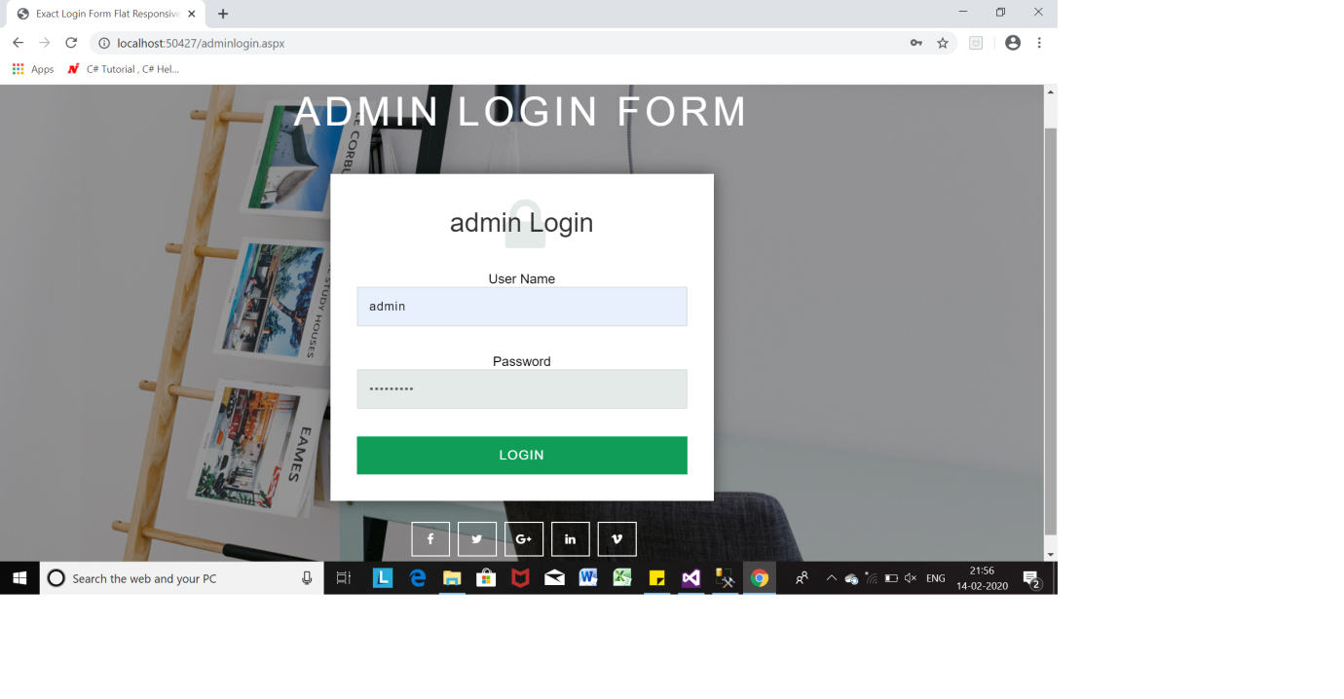

**ADMIN LOGIN**

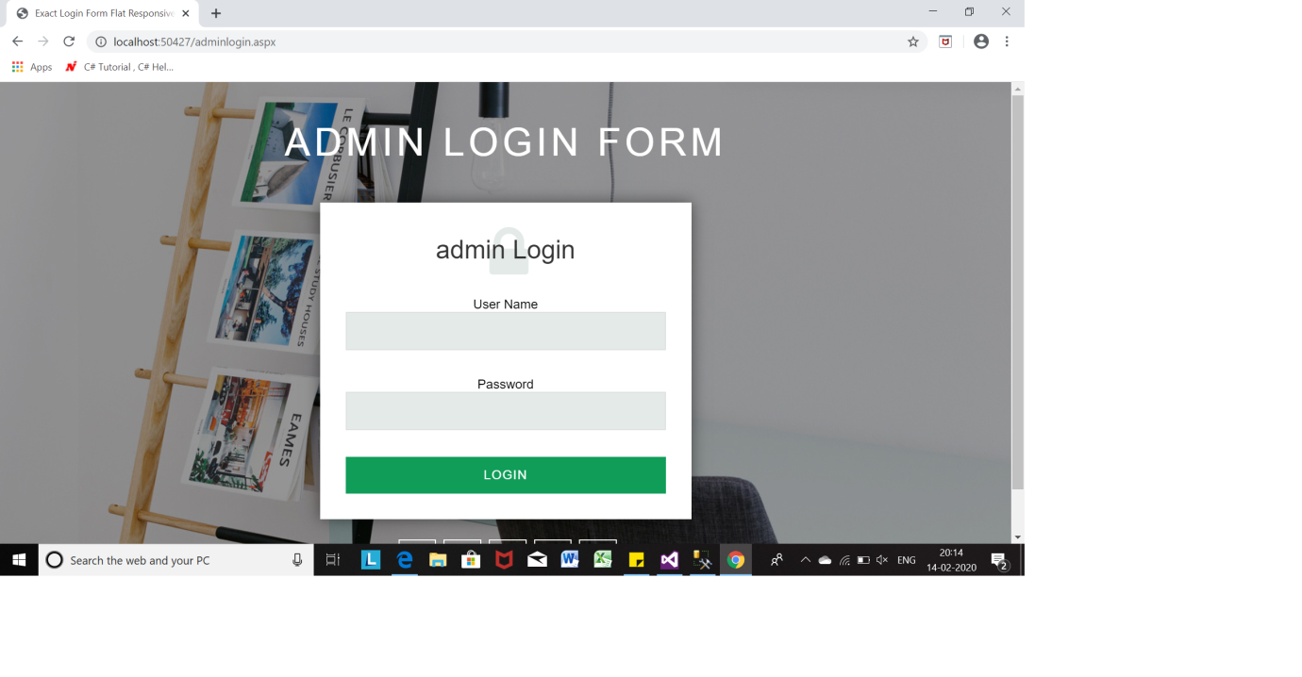

**ADMIN HOME**

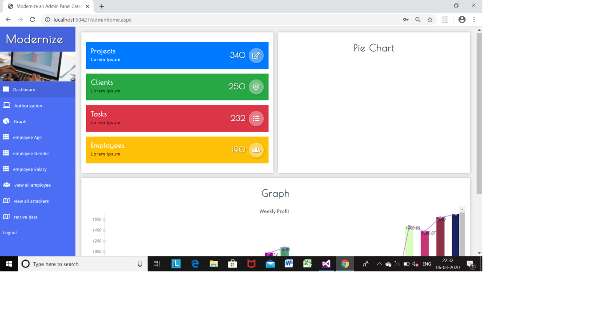

**Authorization**

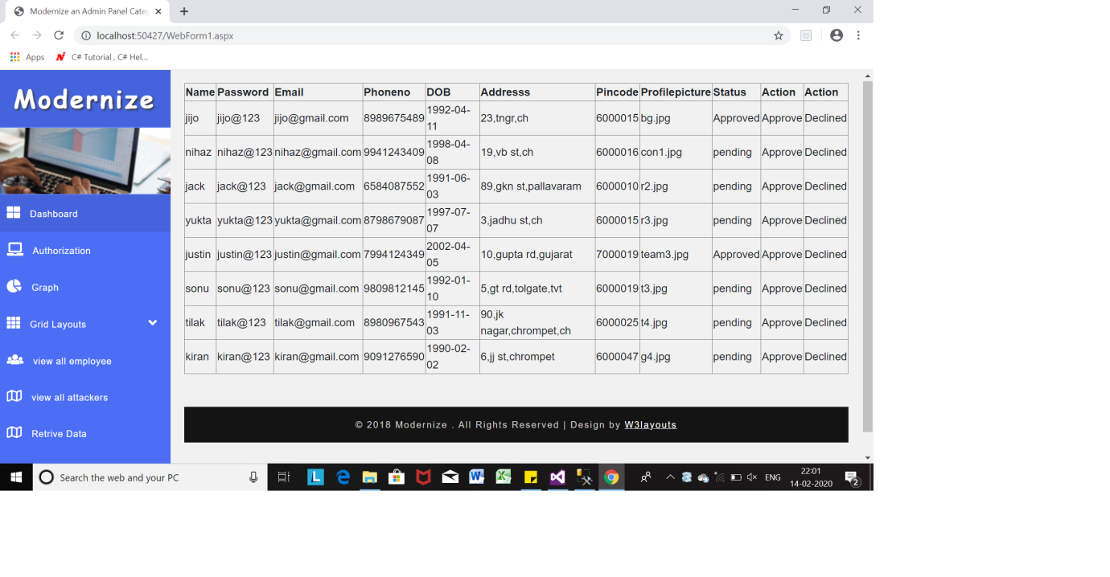

**COUNT ON AGE**

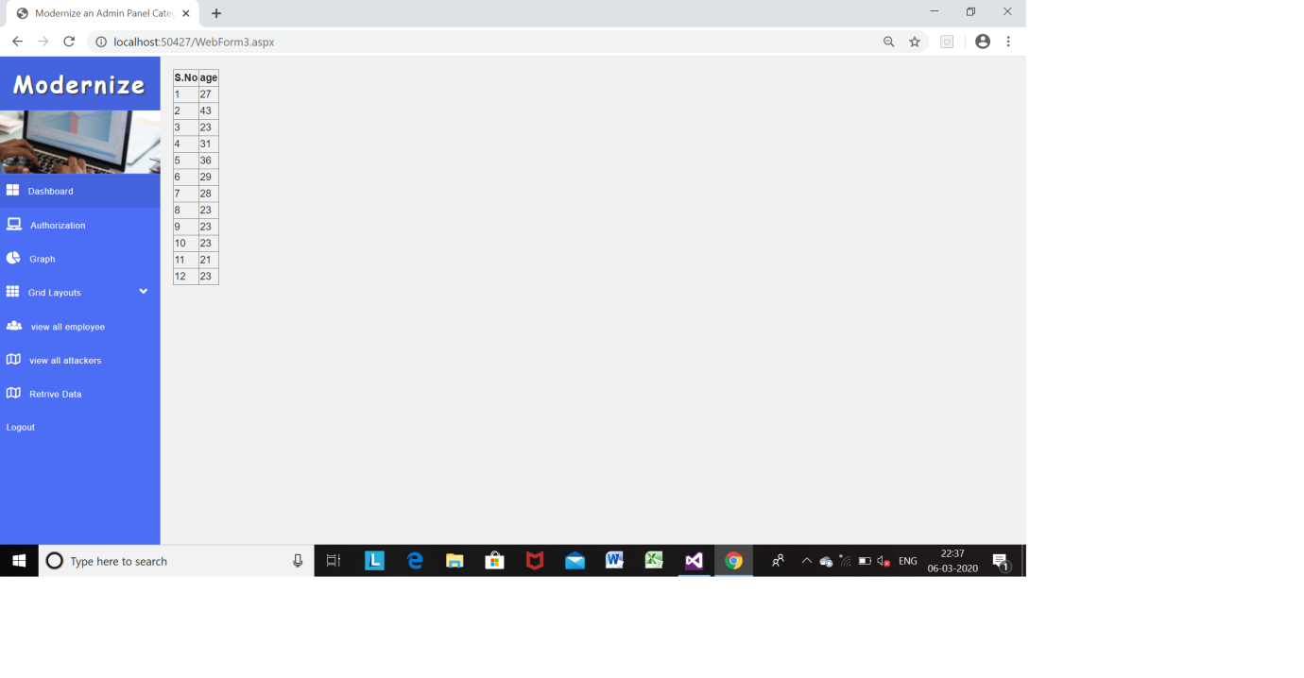

**COUNT ON GENDER**

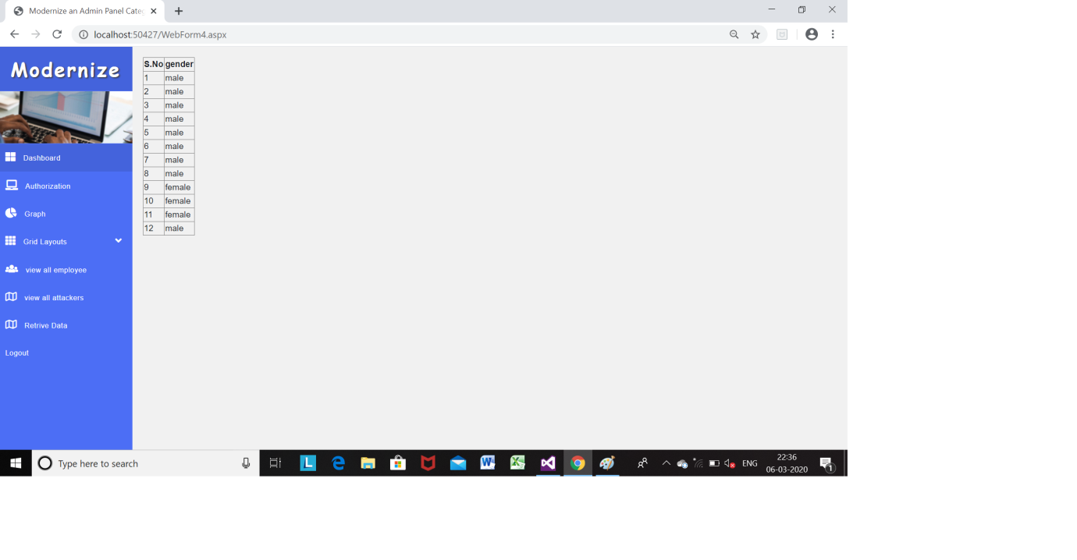

**COUNT ON SALARY**

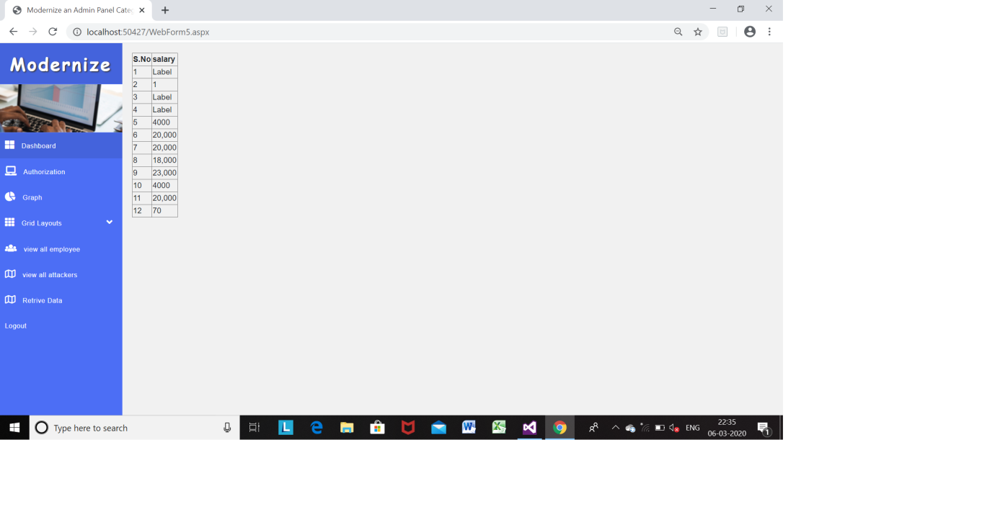

**GRAPH VIEW**

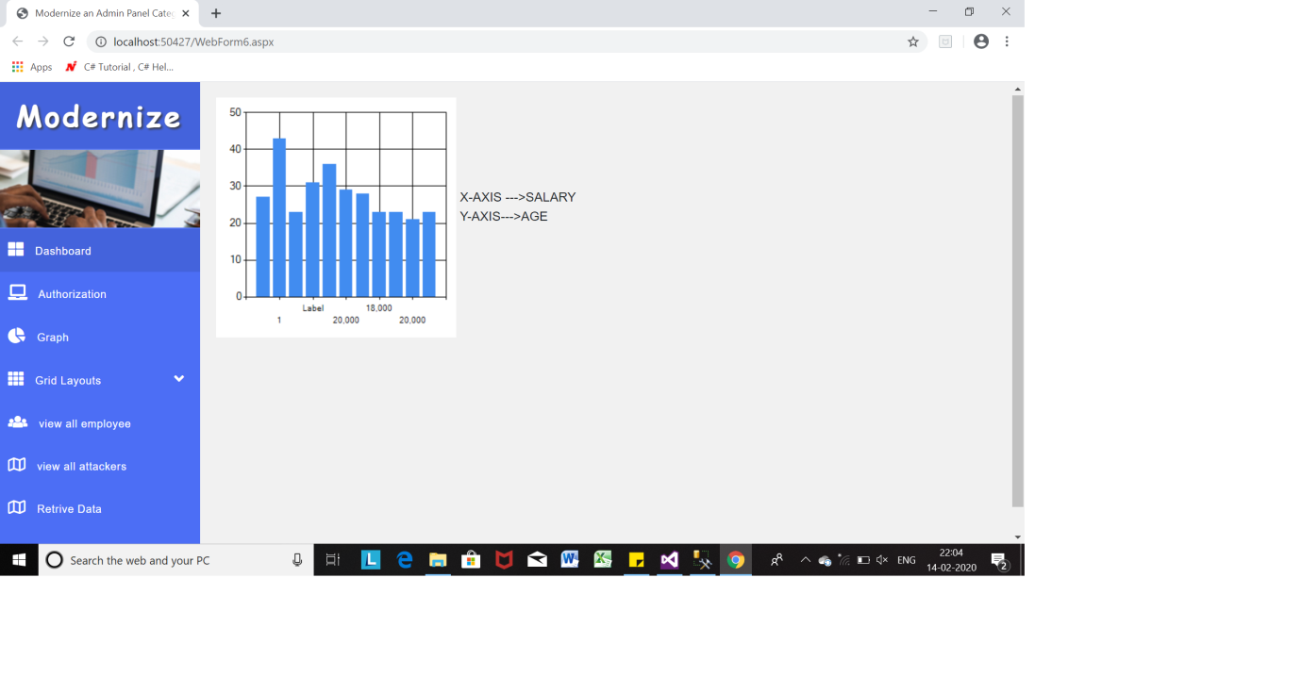

**HOME PAGE**

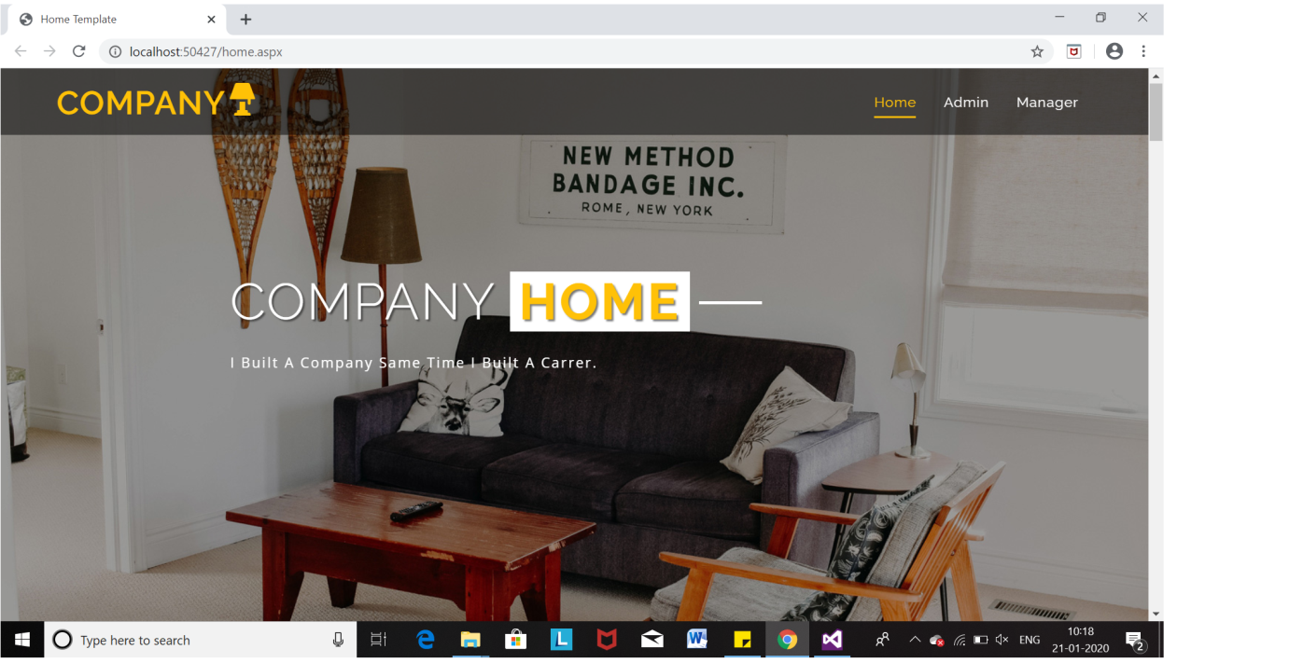

**MANAGER LOGIN**

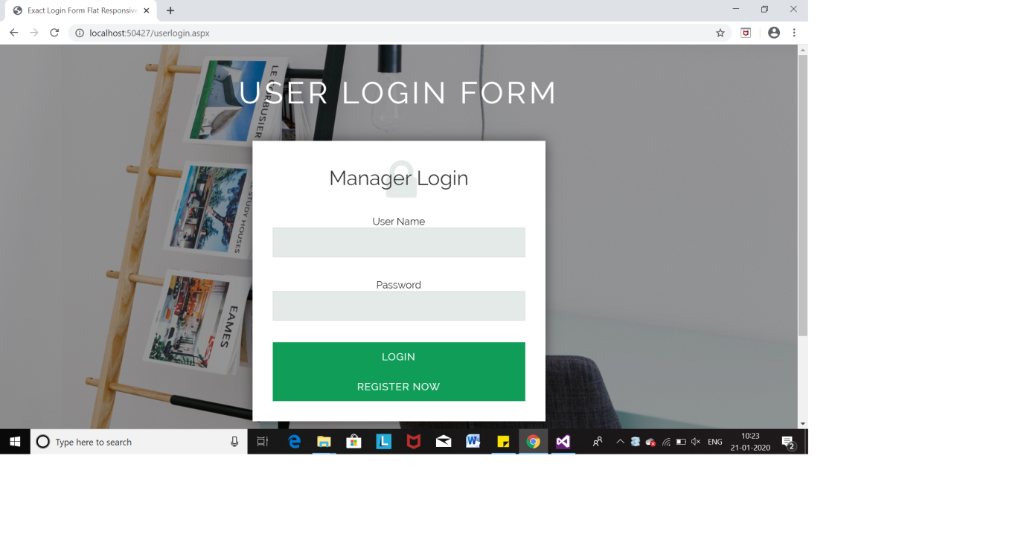

**MANAGER REGISTRATION**

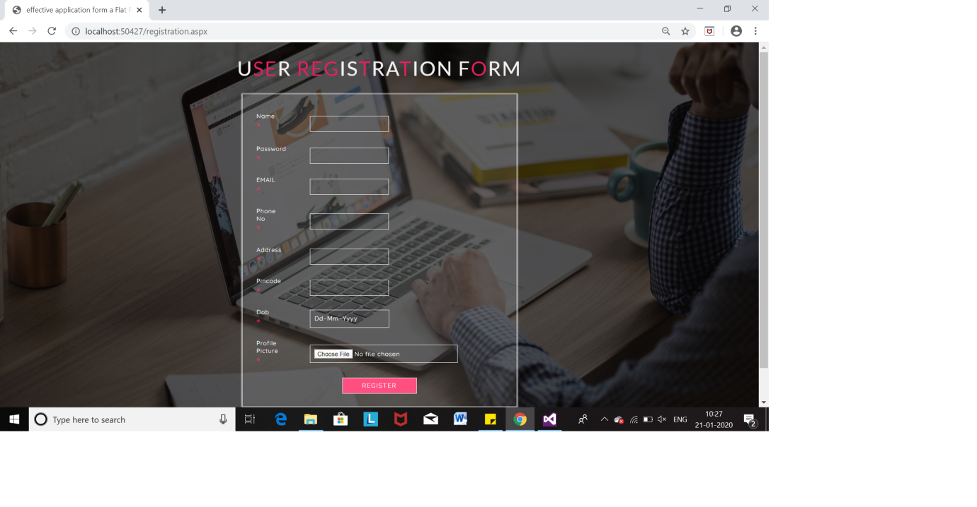

**REGISTRATION VALIDATION**

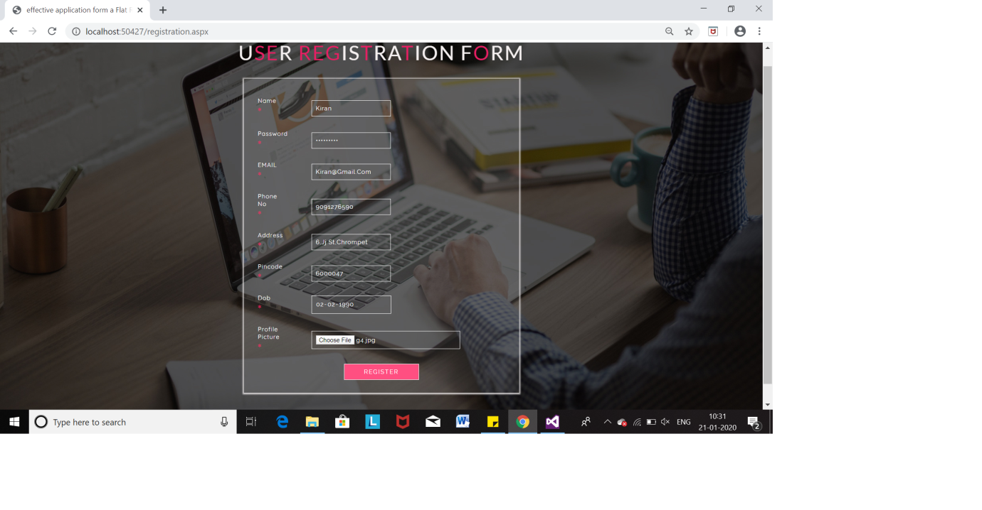

**RETRIVED DATA**

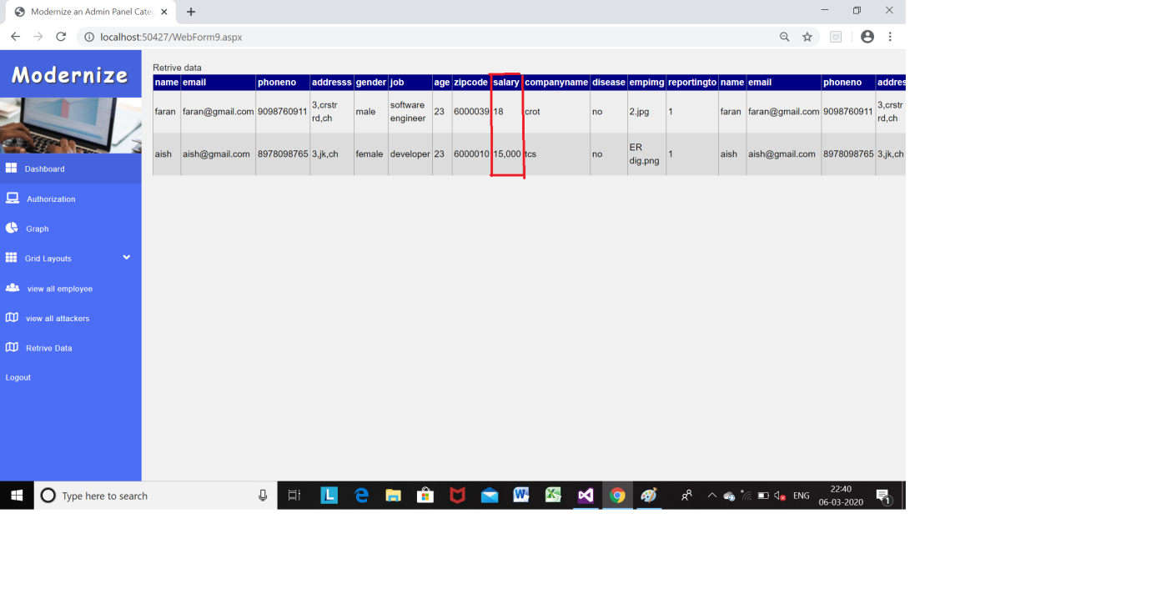

**USER PROFILE**

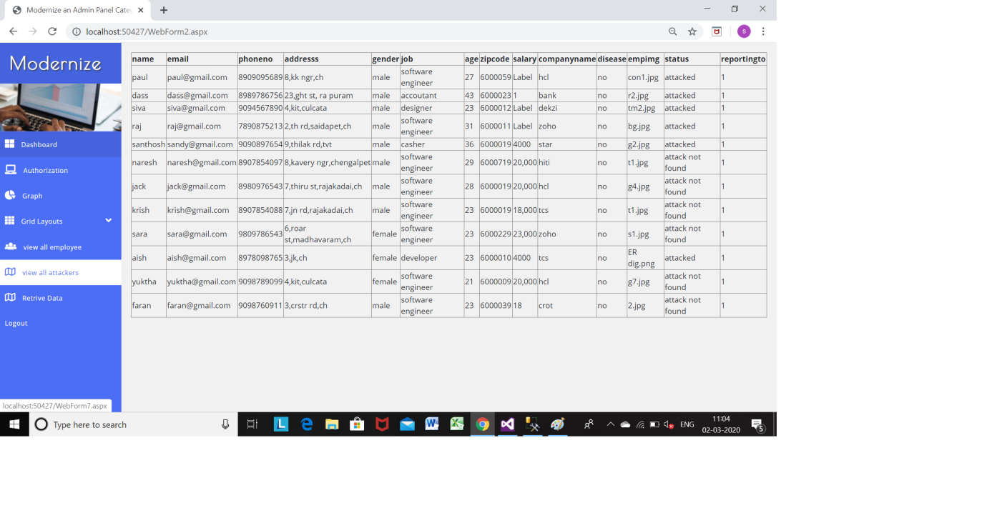

**VIEW ATTACKER**



**VIEW EMPLOYEE**

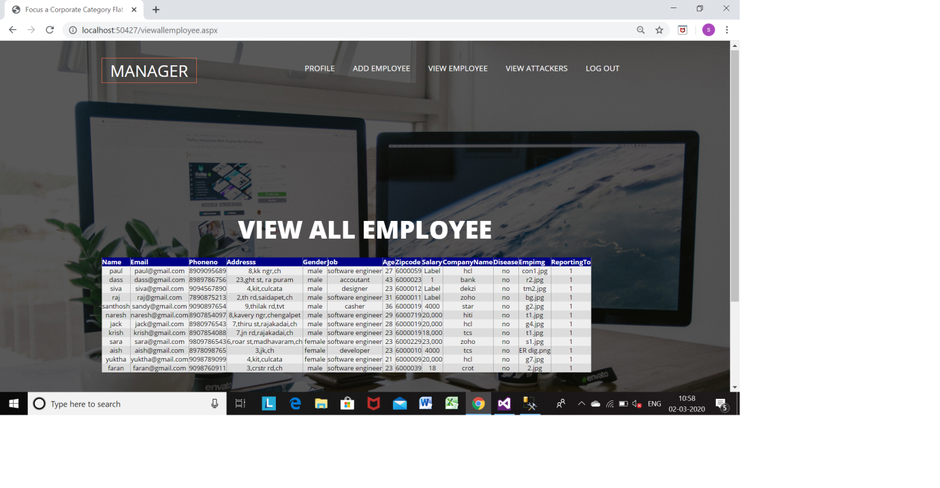

**REFERENCE**

[1] Y. Wang, L. Xie, B. Zheng, and K. C. Lee, “High utility kanonymization for social network publishing,” Knowledge and

Information Systems, vol. 41, no. 3, pp. 697–725, 2014.

[2] Y. Xu, T. Ma, M. Tang, and W. Tian, “A survey of privacy preserving data publishing using generalization and suppression,”

Applied Mathematics and Information Sciences, vol. 8, no. 3, p. 1103,

2014.

[3] N. Victor, D. Lopez, and J. H. Abawajy, “Privacy models for big

data: a survey,” International Journal of Big Data Intelligence, vol. 3,

no. 1, pp. 61–75, 2016.

[4] B. Fung, K. Wang, R. Chen, and P. S. Yu, “Privacy-preserving data publishing: A survey of recent developments,” ACM Computing

Surveys (CSUR), vol. 42, no. 4, p. 14, 2010.

[5] L. Sweeney, “k-anonymity: A model for protecting privacy,” International Journal of Uncertainty, Fuzziness and Knowledge-Based

Systems, vol. 10, no. 05, pp. 557–570, 2002.

[6] M. Rajaei, M. S. Haghjoo, and E. K. Miyaneh, “Ambiguity in social network data for presence, sensitive-attribute, degree and relationship privacy protection,” PloS one, vol. 10, no. 6, p. e0130693, 2015.

[7] X. Xiao and Y. Tao, “Anatomy: Simple and effective privacy

preservation,” in Proceedings of the 32nd international conference on

Very large data bases. VLDB Endowment, 2006, pp. 139–150.

[8] T. Li, N. Li, J. Zhang, and I. Molloy, “Slicing: A new approach for privacy preserving data publishing,” IEEE transactions on knowledge and data engineering, vol. 24, no. 3, pp. 561–574, 2012.

[9] K. Tadisetti, P. Madhuri, and J. B. Shastri, “Implementation of

slicing technique for privacy preserving data publishing,” Journal

of Neurophysiology, vol. 114, no. 3, pp. 1538–44, 2015.

[10] M. Wang, Z. Jiang, Y. Zhang, and H. Yang, “T-closeness slicing:

A new privacy-preserving approach for transactional data publishing,”Informs Journal on Computing, vol. 30, no. 3, pp. 438–453,2018.